**Section -1**

Machine learning used for - predicting future, predicting behavior, use it to get unknown information, look for logic in field you are studying (Clustering)

Interactive Machine learning - Decide which ads to place to customer based on his previous searches and interests.

Deep learning - Face detection and lie detector

Pattern detection

ML is a big science that has everything

Artificial Intelligence

Sophisticated ML - scientific term

Diff b/w AI and ML - AI is a machine that is intelligent enough to do it

Data scientist - ML scientist vice versa

List of imp areas of ML - Regression (Predicting continuous values), Classification (predict category), Clustering, Association rule learning , Reinforcement Learning, Natural Language Processing, Deep Learning(Voice/Face Recognition), Dimensionality Reduction (Capture important variance in data)

**Steps In Building a Machine Learning Models -**

* **Load the data**
* **Create a matrix of independent variables** from the observations (Features)
* **Create dependent variable vector** from the observations (Labels) - Pandas
* **Handling missing data** - Take mean of the columns and fill in the missing data. Deleting the lines having missing data will delete crucial information. - Imputer
* **Encode Categorical data** (Text into numbers)

Problem - After encoding the independent category values - [0,1,2], ML Algorithms treat these as relative values in their equation. So, to prevent that, we will have 3 separate columns for three categories. Labelencoder encodes the values without bothering if there is an order or not. So, we use another class - OneHotEncoder

* **Split the data into training set** on which we build the ML Model and test set on which we test the performance of the ML Model and check whether the model can adapt to new data set or not. Once ML understands the correlation between the independent variables and the dependent variables, then we test how well the model applies this correlation to unseen data/test set. Overfitting
* **Feature Scaling** - We need to put variables on the same scale in ML Algorithms because they calculate using Euclid Distance method. If one of the independent variables scale is higher, then it dominates the calculation. It is as if the other independent variable doesn't exist at all. So, we bring the independent variables to the same scale. In this case, we don't apply feature scaling to dependent variables because it has only two discrete values. But in case of regression, we will apply feature scaling to test set also because it will have a range of continuous values.

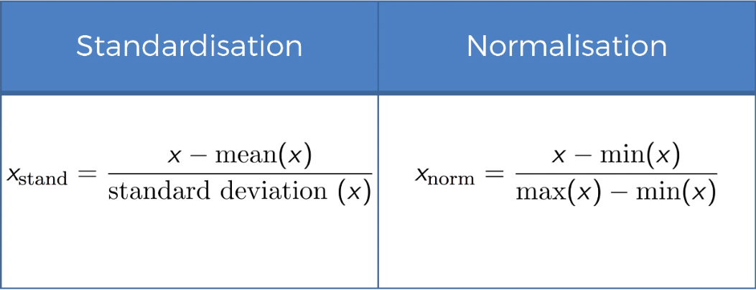

**Section - 2**

Regression models (both linear and non-linear) are used for predicting a real value, like salary for example. If your independent variable is time, then you are forecasting future values, otherwise your model is predicting present but unknown values. Regression technique vary from Linear Regression to SVR and Random Forests Regression.

Machine Learning Regression models:

**Simple Linear Regression Model –**

y = mx + c (y is the dependent variable, x is the independent variable). SLR has only one independent variable. m is the factor that tells how a unit change in x affects a unit change in y. c is the constant term. Trend line that best fits the data.

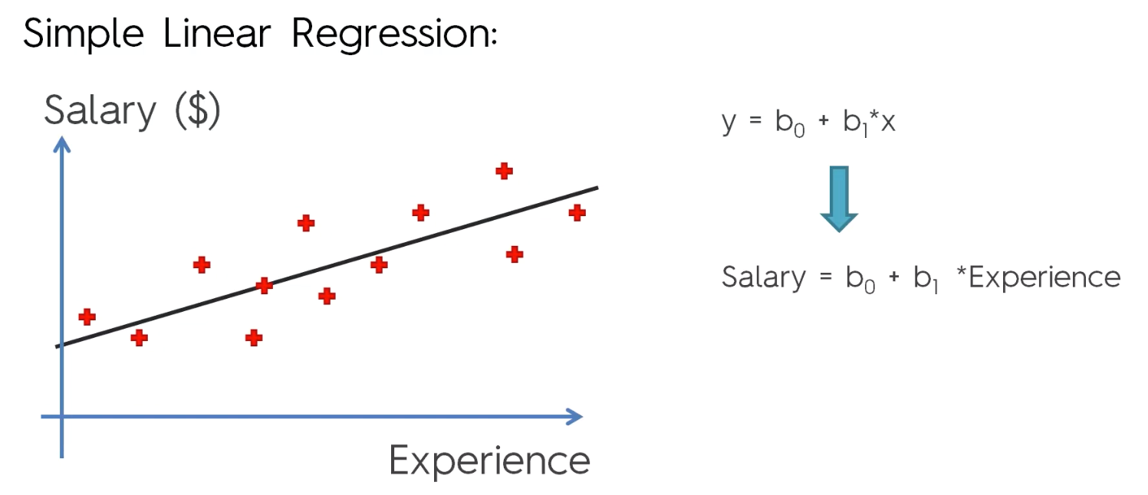

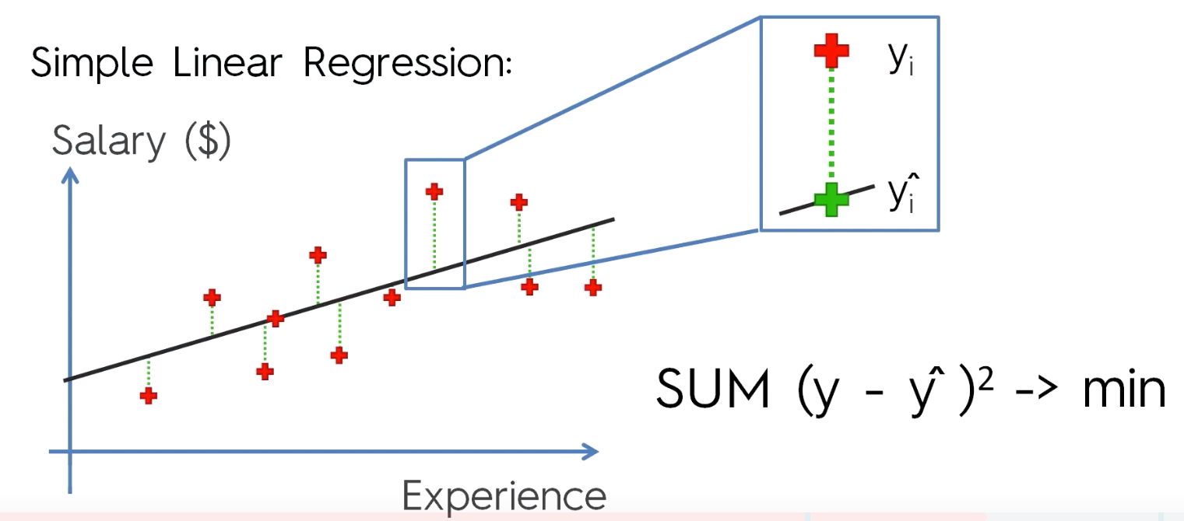

In SLR, the algorithm draws lots and lots of these y = mx + c lines. Then finds the square of the difference between the actual values and values that is predicted by the model for each data point. Then finds the sum of these values. And where this sum of square of differences is minimum, that line is treated as the best fitting line. This method is called **Ordinary Least Squares method**.

Ex: Built a Simple Regression Model for Number of years of experience vs Salary statistics. It performed good on unseen dataset. Implementation done in both python and R. Graphs were plotted in the end for visualizing the results. And according to the model, most of the test set results matched with the original data, although there were some subtle differences.

**Multiple Linear Regression –**

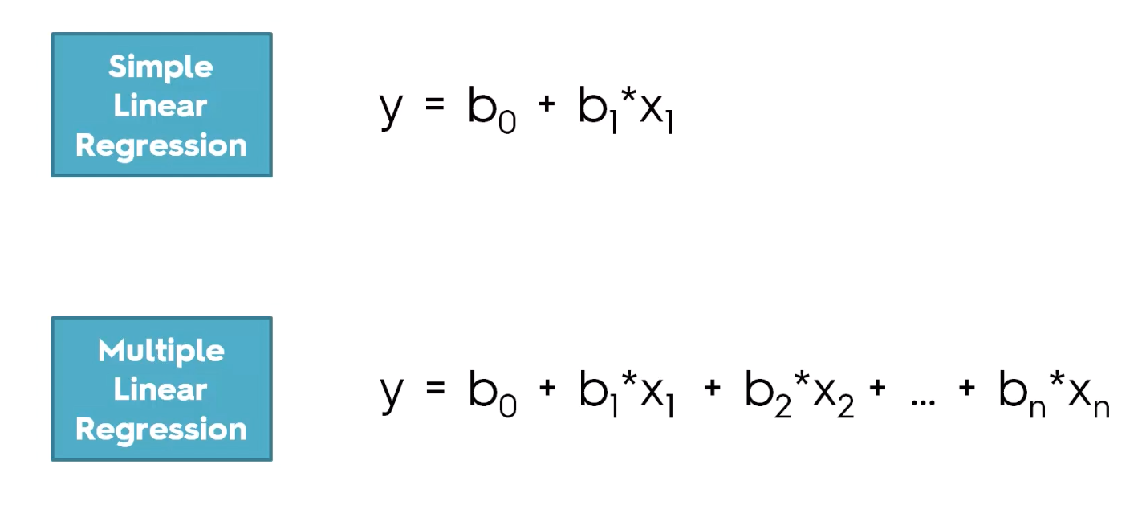

**Limitations/Assumptions of Linear Regression –**

Check if these assumptions hold good and then only proceed for building Linear Regression Model.

1. Linearity
2. Homoscedasticity
3. Multivariate Normality
4. Independence of Errors
5. Lack of multicollinearity

Given dataset, first check for all the numerical and categorical values. All categorical values must be converted to dummy variables, the dataset is extended.

You don’t include all the dummy variables in the regression model. By default, the model will assume that if any variable is not included, then the constant **b0** in the equation represents that dummy variable.

**Dummy Variable Trap –**  You cannot include both dummy variable in a model.

D2 = 1 – D1

The phenomenon where one or several independent variables predict another independent variable is called **multi-collinearity.** Due to this model cannot distinguish between the effects of D1 and D2,  So the model won’t work properly.

This is called Dummy Variable Trap. The constant, and two dummy variables cannot be present in the equation. If you have 9 then you should include 8 dummy variables, if you have 100 , then you should have 99 dummy variables.

**P- Value** - The probability of getting an unusual value if the null hypothesis is true.

Ex- When tossing a coin, the probability of getting heads is 0.5 (50%), given the condition that the coin is fair. **Null hypothesis (H0)** Is something that we believe to be true while we evaluate the outcome of our experiment. Probability of getting two heads in a row – 25%. Probability of getting three heads in a row – 12.5%. Probability of getting four heads in a row – 6.5%. Probability of getting five heads in a row – 3%. Probability of getting two heads in a row – 1.6% if the coin is fair. So, getting 6 heads in a row is enough to reject the null hypothesis that the coin is fair and we would except the alternative i.e. HA. For this experiment, what is the significance alpha? Alpha is 1- level of confidence you need in rejecting the null hypothesis. 1 - Alpha in this case is the confidence to accept that null hypothesis not true. Here alpha = 3% and C = 97%. P-value is the probability of getting an unusual result if the null hypothesis is true. So, P-value for this experiment is 1.6%, which is the probability of getting 6 or more heads in a row out of 6 tosses.

**If 0.016 < 0.03,**

**P < ALPHA, then REJECT THE NULL.**

**P-Value** tells us how likely we might get this result, if the hypothesis is true. Higher the P-value, higher the chances that our hypothesis being true. **P is LOW, Null must GO**. Significance value usually is 0.05.

In **multiple linear regression**, there are multiple independent values that play a role in predicting the dependent variable. Some of the data (independent variables) must be discarded for the prediction. Why? Reasons are –

1. Garbage in = Garbage Out. If you put too much data into the model, then it won’t be a good model. It won’t be reliable.

2. Explain variables, understand math, what they mean how they affect your predicting variable. Keep only important ones that actually predict something.

So, there are 5 methods of building models –

1. **All-in** – Throw in all your variables. You already have prior knowledge about the domain, you know that all of them are True Predictors. You might have to use this if your company demands (banking system to estimate if a credit defaults or not). Other times, you use this method, when you are preparing for backward elimination.
2. **Backward Elimination – (**Faster one of all the methods**)**

1. Select significance level to stay in the model (default (Significance Level) SL value = 0.05)

2. Fit the model with all possible predictors (Use All-In approach)

3. Consider the predictor with highest P-Value. If P-Value > SL, go to next step, else go to finish.

Here the Null Hypothesis is – The predictors are randomly affecting the dependent variable. So, higher the P-value for a predictor, it means that there are higher chances that the effect of predictor on dependent variable is random. So, lesser the P-value for a predictor (< SL), we keep the predictor variable for fitting it into the regression model and we reject the null hypothesis. Higher the P-value, we accept the null hypothesis and reject the predictor variable.

4. Remove the predictor having highest P-value.

5. Fit model without this variable. Here, removing a variable, effects all the other variables, it will change the constant term, the coefficients and the equation.

6. Repeat from step – 3.

7. Finish – Model is ready

1. **Forward Selection –**

1. Select a significance level to enter the model

2. Fit all simple regression models y ~ Xn, select the one with lowest value. Take the dependent variable and create a simple regression model with every independent variable we have. Out of all those models, we select the one which has lowest P-value.

3. Keep this variable and fit all possible models with one extra predictor added to ones you already have. Take the independent variable from previous step and all the other independent variables one by one and create simple regression models with two variables where one of them is from previous step. Add on all other independent variables one by one.

4. Consider the predictor with lowest P-value out of all two variable simple regression models. If P< SL, go to step 3, otherwise go to finish. Grow one variable at a time.

5. Finish – Your model is ready.

1. **Bidirectional Elimination – More general approach, mostly implied by stepwise regression**

1. Select a significance level to enter the model and to stay in the model. SLENTER = 0.05 and SLSTAY = 0.05

2. Perform step 2 of forward selection. New variables must have P < SLENTER to enter the model.

3. Perform all the steps of backward elimination. Old variables must have P < SLSTAY to stay.

4. Go to Step 2 until no new variables can enter and no old variables can exit

5. Finish – Your model is ready

1. **Score Comparison (All Possible Models) (**Highly resource consuming)

1. Select a criterion for goodness of fit. -Ex- Akaike Criterion

The **Akaike information criterion** (AIC) is an estimator of the relative quality of statistical models for a given set of data. Given a collection of models for the data, AIC estimates the quality of each model, relative to each of the other models. Thus, AIC provides a means for model selection.

2. Construct all possible regression models. If you have n independent variables, then you have 2n – 1 models.

3. Select the one with best criterion.

4. Finish - Model is ready

**Stepwise Regression** (2,3,4)

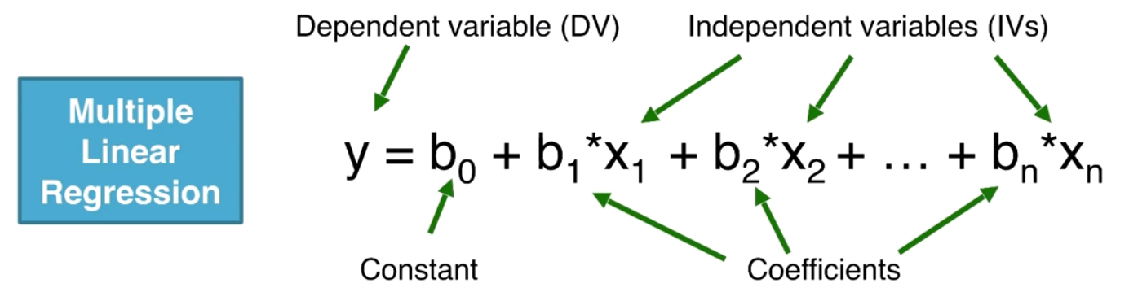

We built a model using multiple linear regression. Now the next step is to build an optimal model using backward elimination. For this process, we use statsmodel to calculate P-value and evaluate the statistics of significance of our independent variables.

Linear Regression models by default have b0 value, they calculate and use it. But statsmodel library don’t calculate the b0 value. So, we have to prepare the dataset for using this library. When we add the one more column at the beginning whose values = 1, statsmodel will understand that there is one more coefficient in the linear equation - b0.

**Polynomial Regression**

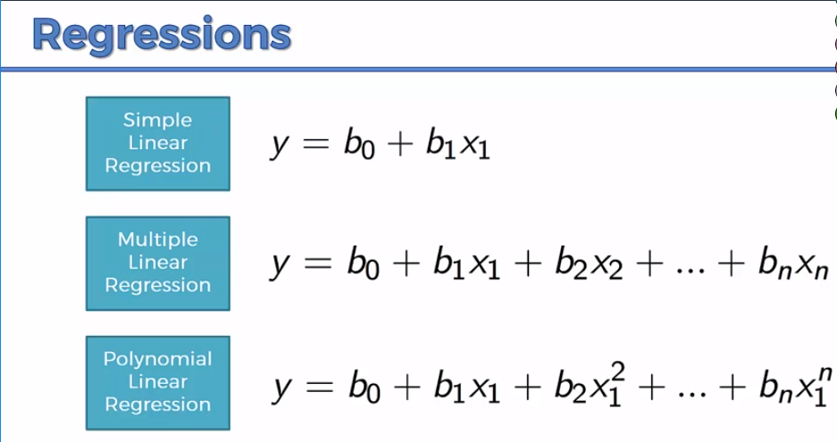

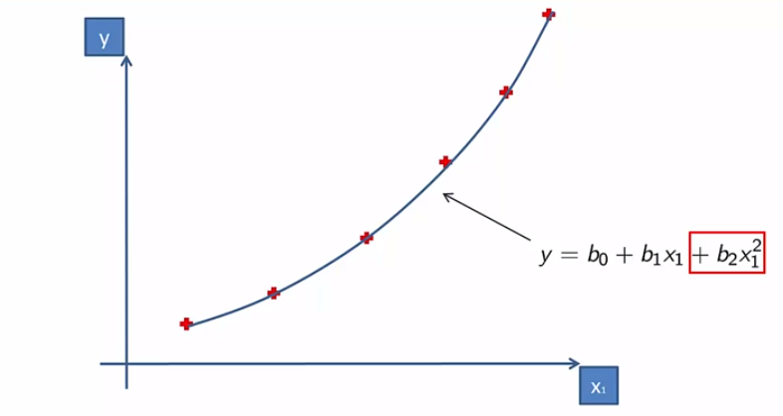

Polynomial Regression is used to to predict diseases – pandemics. (Parabolic Curve)

When we talking about linear regressions, we are talking about the coefficients, not the x-variables.

**Tip :** Before working on machine learning model, just plot a graph of independent variable vs dependent variable, so you will know whether the dependent variable is linearly related or polynomial related to the independent variable. This will give us rough idea on which model to use.

**Tip:** Also, make sure X is a Matrix and Y is a vector in case of Regression to avoid errors and warning.

Each level in the given example is mapped to position already, so we need not use the first position column.

Keep increasing the degree until it fits perfectly.

**Support Vector for Regression (SVR) –** Refer notes made from MIT lectures.

**Decision Tree Classification-**

CART – Classification and Regression Trees

Regression Trees – Complex than Classification Trees.

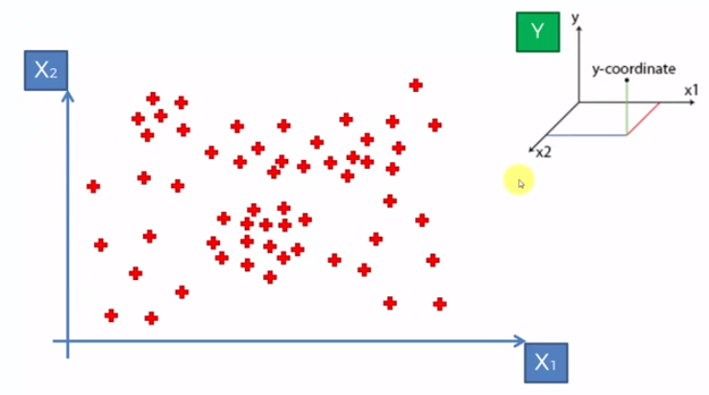

Output of Decision Tree Algorithm - Splitting of data into multiple segments.

How and where these splits are conducted?

Looking at Information Entropy – When I perform a split, is this split increasing the amount of information that I have about the points, is it adding some value to the way we want to group our points? Each split is called a **Leaf**. When we conduct a split, if we have less than 5% of total points in a leaf, then we ignore that leaf. That is when the splitting stops. Final leaves are called **Terminal Leaves**.

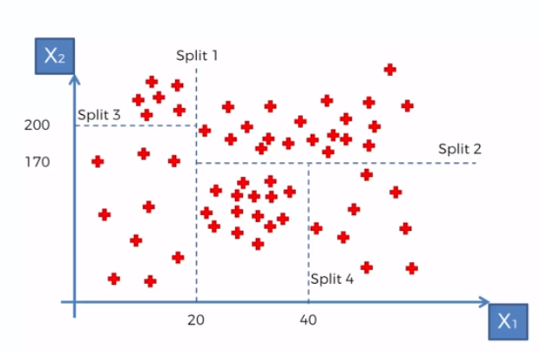

How decision tree is created?

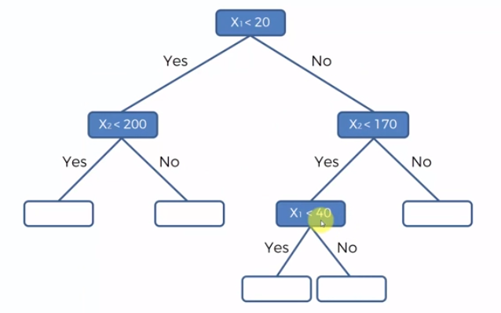

How splitting of data points into terminal leaves help us to predict the Y-value of a new data point? Take the averages of each of your terminal leaf. And that will be the value that is assigned to each new data point that falls in the terminal leaf.

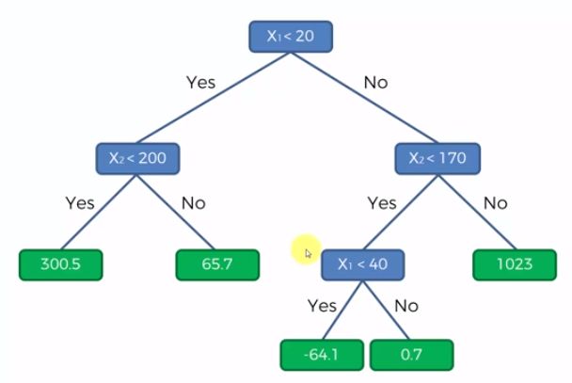

**Decision Tree Regression** **Non-Linear and Non-Continuous Regression Model.**

Decision Tree Classifier repetitively divides the working area(plot) into subpart by identifying lines. Repetitively because, there may be two distant regions of same class divided by other.

Consider the below plot –

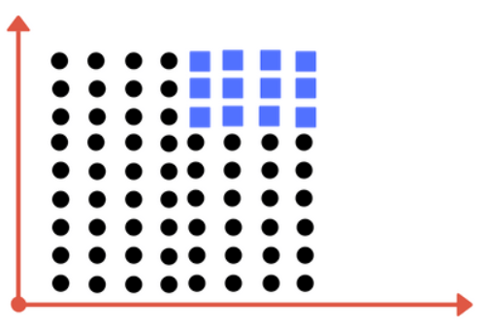

We need more than one line here to divide the plots into classes – one for the threshold value of x and the other for the threshold value of y. And this is what is achieved using Decision Trees.

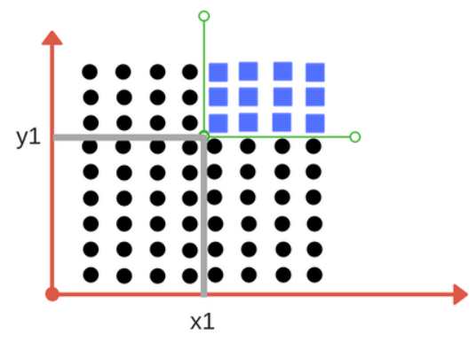

When does it terminate?

1. When it has divided into classes that are pure (Only containing members of single class)

2. Some criteria of classifier attributes are met.

**Impurity** – When we have traces of one class division into another. This occurs due to following reasons-

1. When we run out of available features to divide the class upon.

2. When we tolerate some impurity for faster performance (Accuracy vs Performance)

**Gini Impurity -** Where we stop the division for second case, when we have fewer number of elements left.

**Entropy** – It is the degree of randomness of elements or Measure of Impurity. Formula is

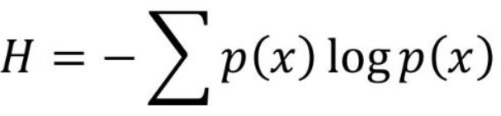

**Information Gain** – Suppose we have multiple features to divide the current working set. What features should we select for division? One that gives less impurity. If we divide the classes into multiple branches, then the information gain at any node is,

**Information Gain (n) = Entropy(x) — ([weighted average] * entropy(children for feature))**

Higher the information gain value, better is the feature. If Information gain value is 0, then it means that the feature doesn’t divide the working set at all.

Dividing efficiently based on maximum information gain is the key to decision classifier.

**Random Forest Classification for Regression Trees –**

It is a version of **Ensemble Learning**. It means you take multiple algorithms or take same algorithm multiple times and put them together to build something that is much more powerful than the original.

Steps –

1. Pick at random k data points from the training set.

2. Build decision tree associated to these k data points. Rather than building decision tree for all the data points in the training set, build decision tree based on a set of points that is subset of your dataset.

3. Choose the number of trees that you want to build. Repeat steps 1 and 2. Build lot of decision regression trees.

4. Finally, use all of them to predict. For a new data point, make each one of your Decision Tree predict the value of Y. Then assign the new data point, the average across all the Y predicted values. By default, there will be 500 trees at least.

Improves accuracy of prediction because you are taking average of many predictions.

It is a **non-continuous regression model** because it is a team of decision tree.

Convergence – Increasing the number of trees will not increase the number of steps, it only results in better location/placement of the steps in the stairs.

**R-Squared -**

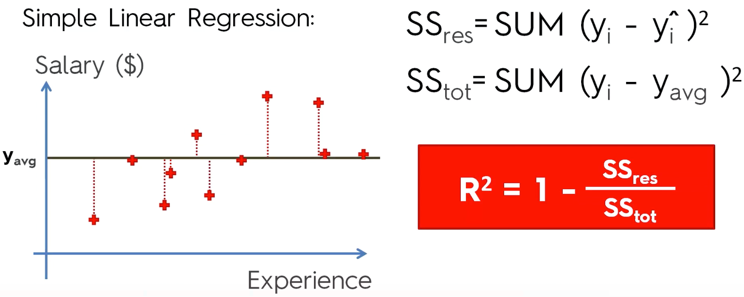

R2 = 1 is the ideal scenario

The closer R2 is equal to 1, the better is the model (The regression line).

R2  irrespective of any dependent variable’s relationship with independent variable, will always increase. Because any independent variable will have some random degree of relationship with dependent variable. So, we wouldn’t know whether adding a new variable will actually improve the model or not. So, we go for adjusted R2  model.

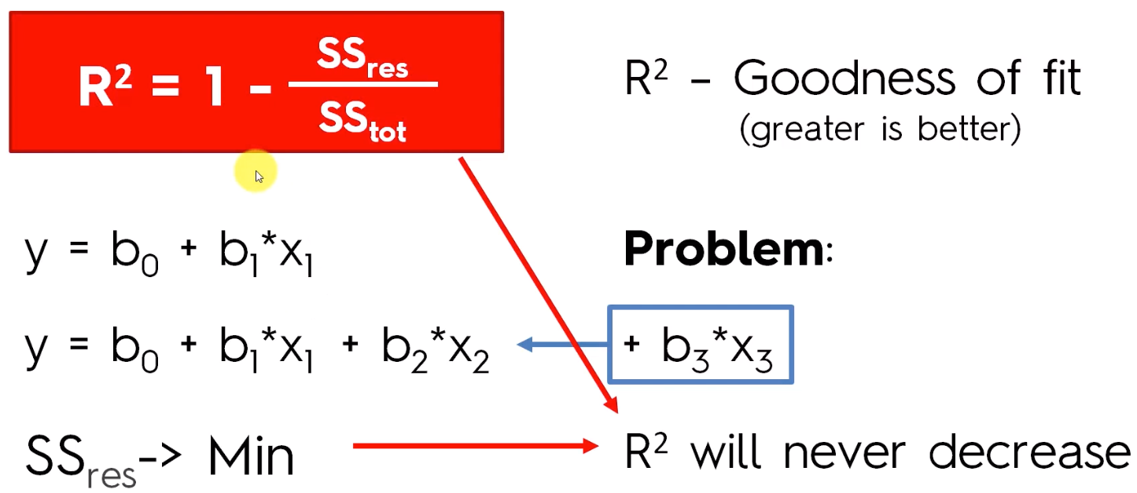

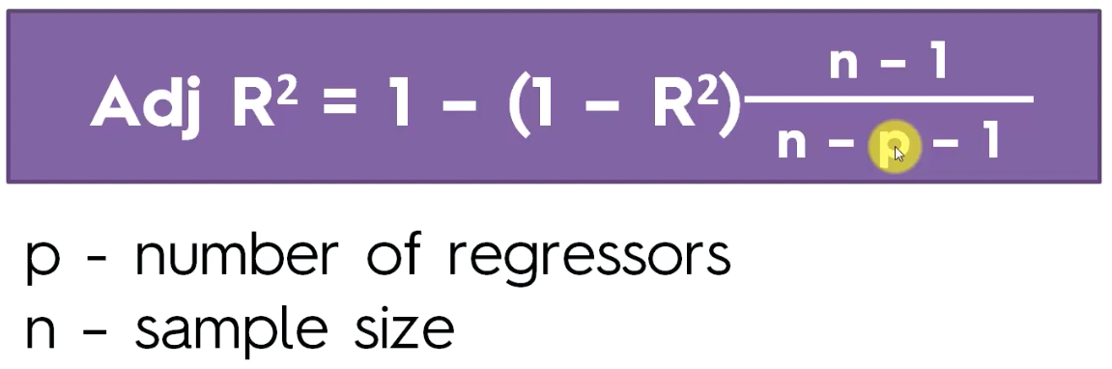

Adjusted R2  has a penalizing factor. It penalizes you for adding new variables that don’t help your model. P is the number of independent variables.

**Classification –**

**Logistic Regression-**

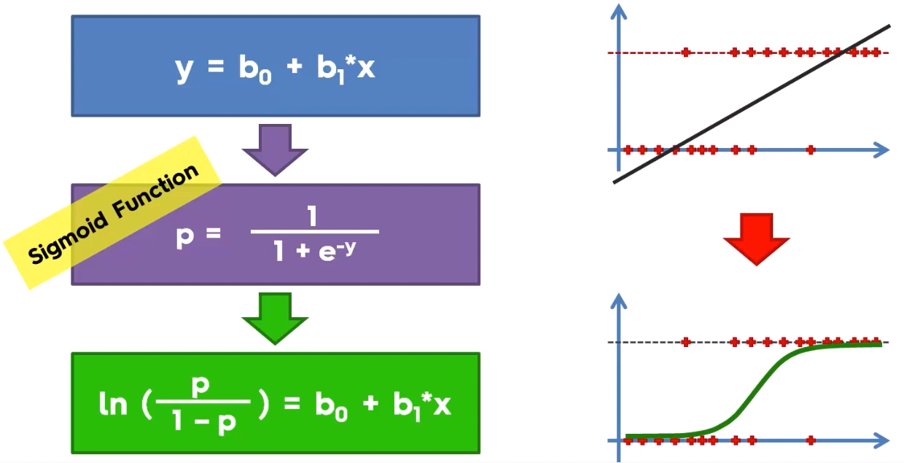

The curve gives the probability that the data point belongs to one of the two categories.

It is a linear classifier so it will skip few points here and there. The separator is a straight line.

**KNN –**

1. we have a dataset where we have already identified two groups in our dataset. When we add new points into the dataset, how do we classify this new points?

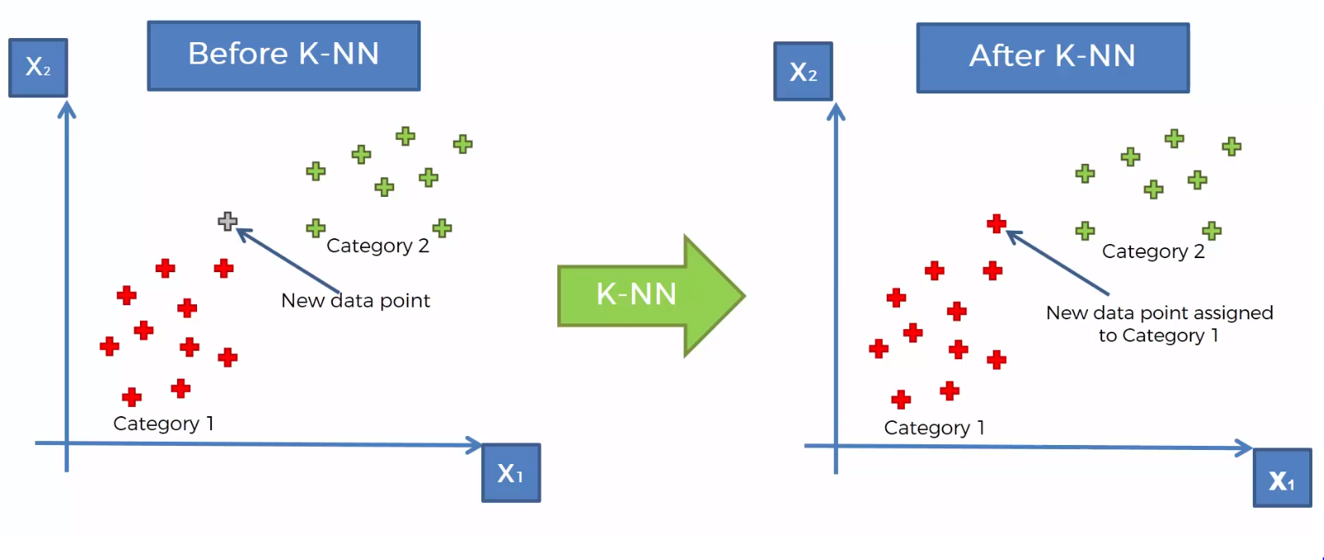

Steps –

1. Choose number K of neighbors

2. Take K nearest neighbors of the new data point , according to Euclidean Distance.

3. Among these K nearest neighbors, count the number of data points in each category

4. Assign the new data point to the category where you counted the most neighbors

5. Your model is ready

It is non-linear classifier, so the separator is a curve.

**Support-Vector Machine –**

Finding the best decision boundary which will help us separate our space into classes.

It draws line in such a way that it separates the two classes of points and at the same time, it has maximum margin.

Assumption: We are working with a linearly separable dataset.

Support vectors are very close to the boundaries. Rather than looking at the heart of the classified objects, SVM looks at the extreme case in the boundaries of separation to construct it’s analysis. That is why they are special and different from other classification algorithm. And correct in their classification prediction most of the time.

When the number of dimensions changes from 2 to multi-dimension, a point is no more called as appoint but is treated as a vector.

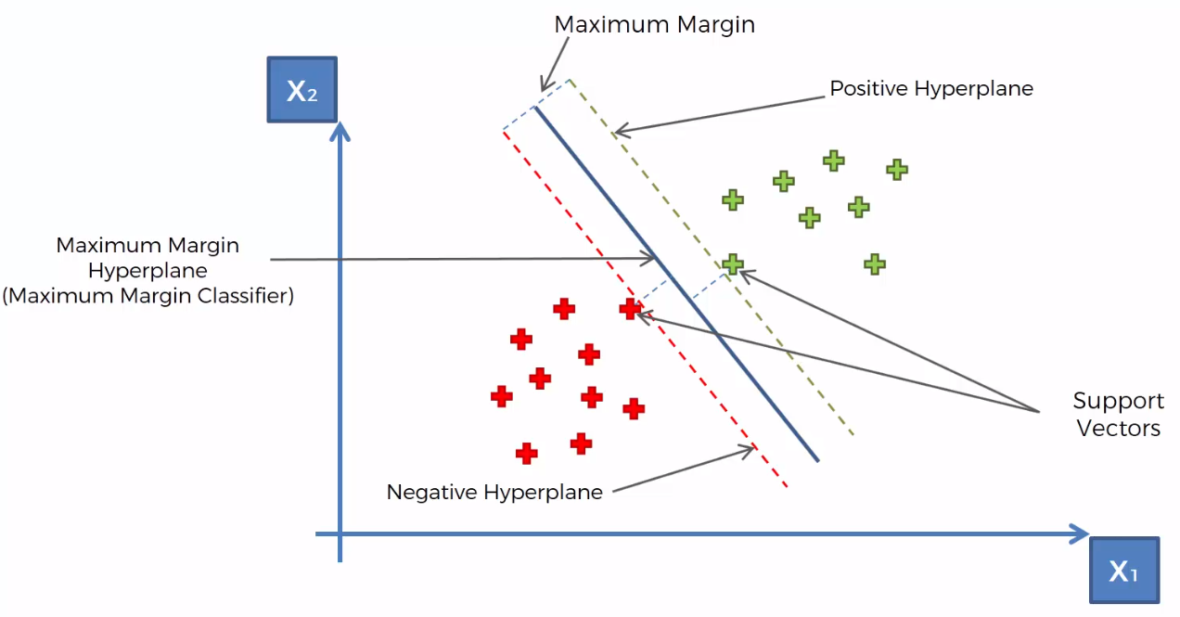

**Kernel SVM -**

Used for data which is not linearly separable.

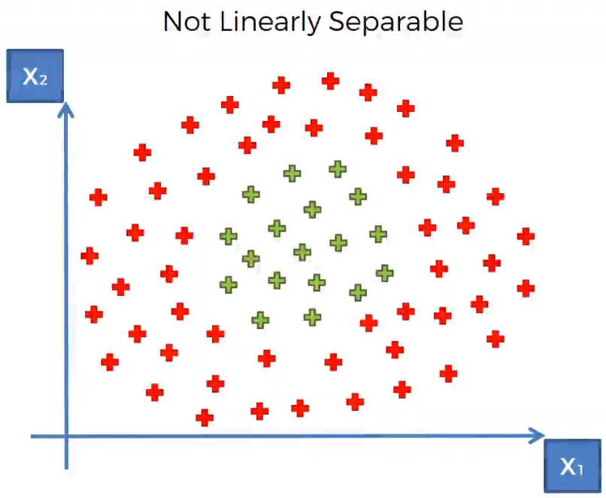

We take the non-linearly separable dataset, and map it to higher dimensional space to make it linearly separable by invoking support vector algorithm and build a decision boundary and then project all of that back to original dimensions.

Converting data points in 1D to 2D to make it linearly separable.

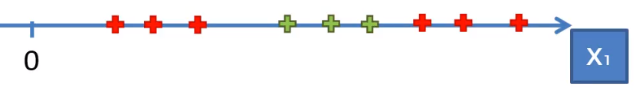

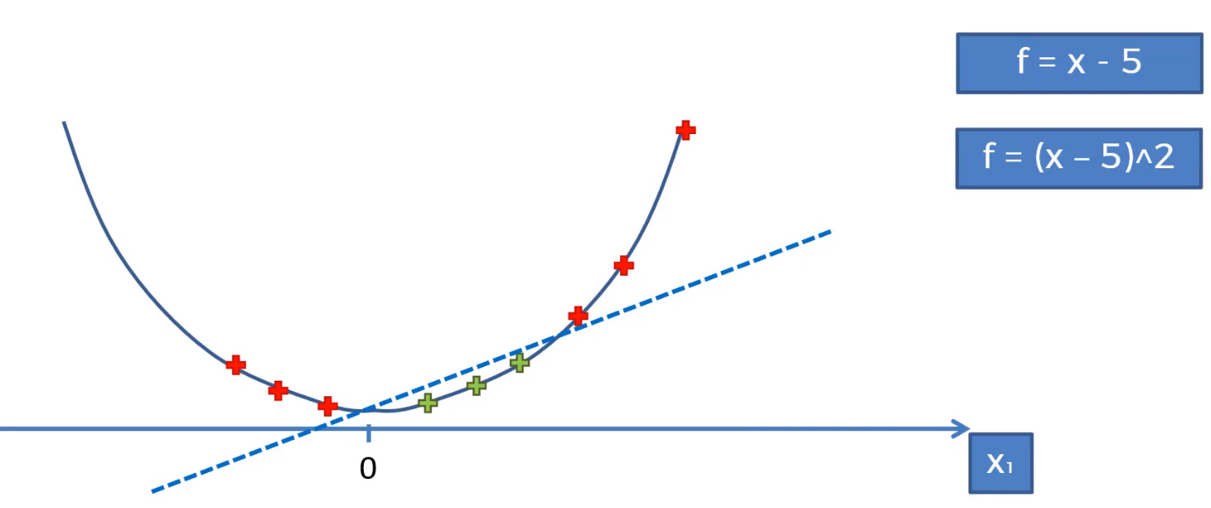

Mapping from 2D to 3D space. SVM can work on data only if it is linearly separable. So, we first convert the data from one dimensions to higher dimensions using a mapping function , make it linearly separable, apply SVM to get the classified regions and then project it back to original dimensions and then predict the new data point.

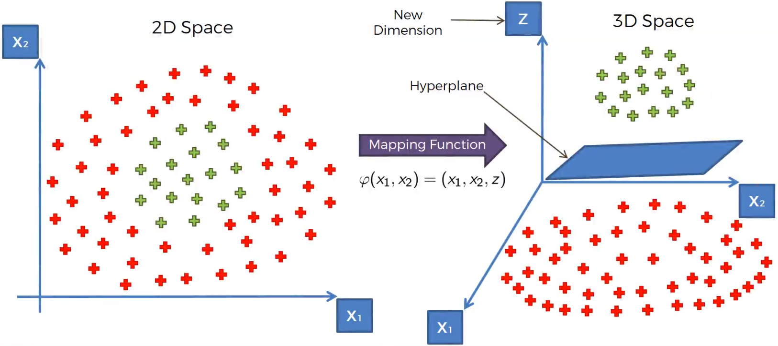

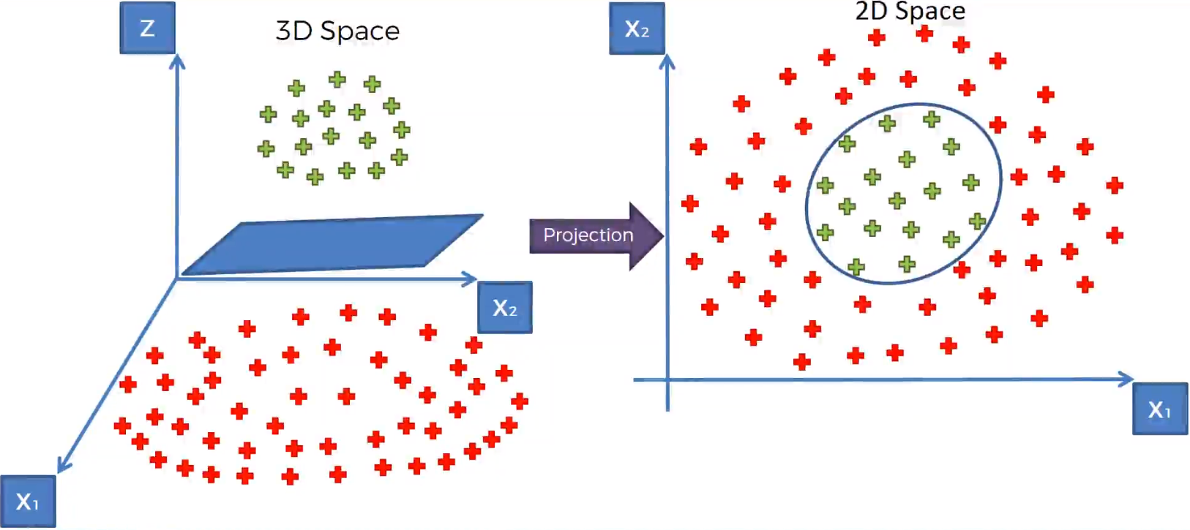

**Catch is “Mapping to a higher dimensional space can be highly compute-intensive”.**

**Solution – Kernel Trick**

Gaussian Radial Basis Functional Kernel –

K – Stands for kernel

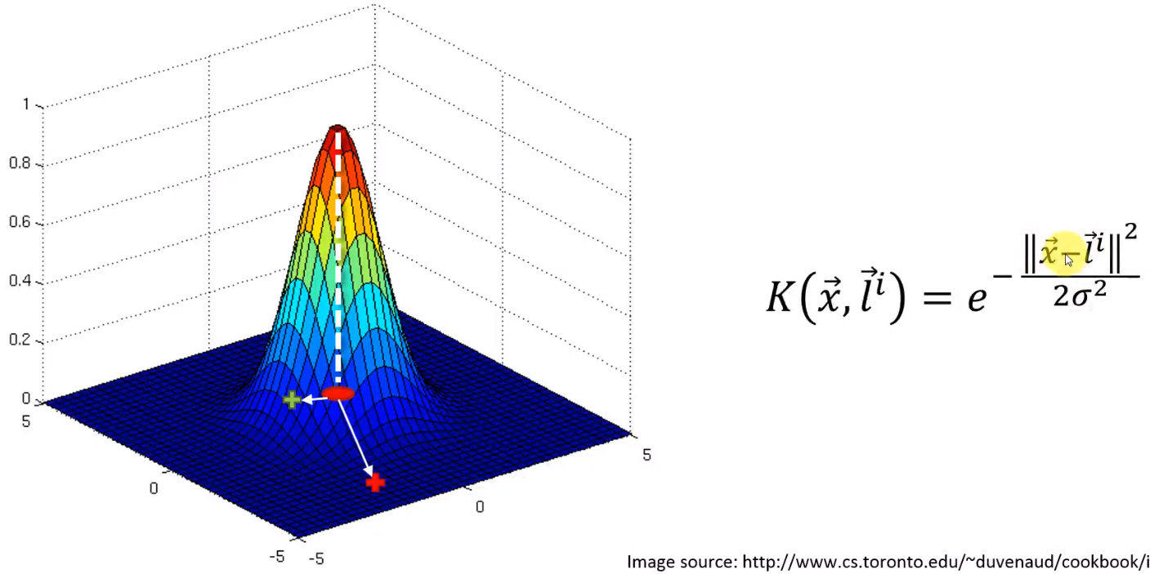

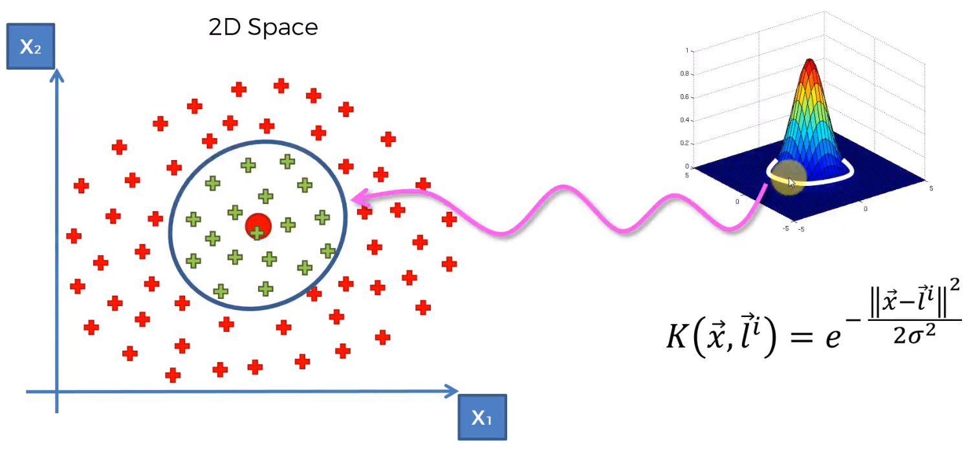

Any point that falls within the circle, will have a value above 1 when the Kernel RBF function is applied.

Any point far away from the circle will have a value of 0 when the kernel RBF function is applied.

Sigma defines the width of the circumference. As value of sigma increases, the width of the circumference increases.

Decision boundary is non-linear.

When you add two kernels –

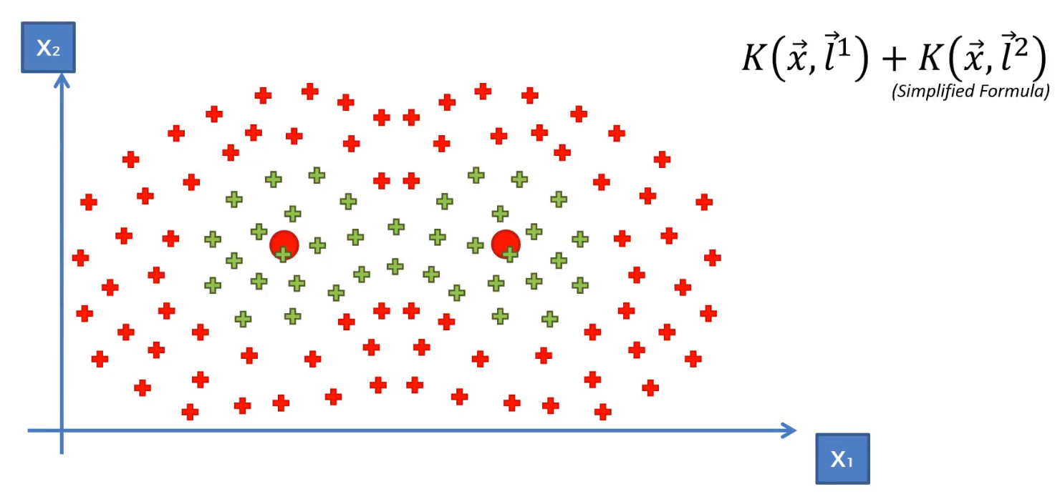

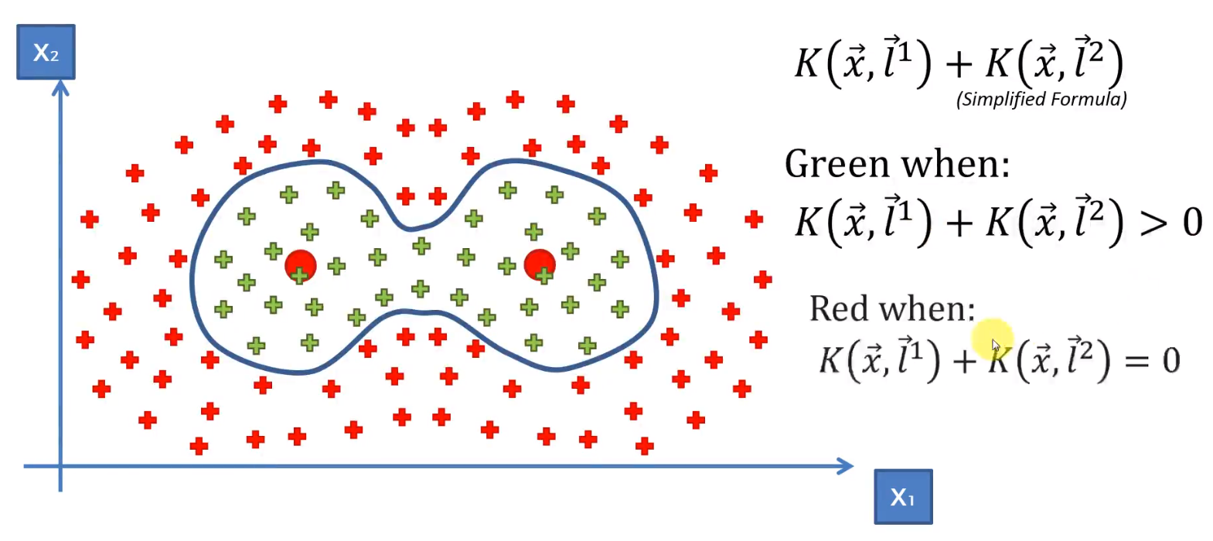

**Types of Kernel –**

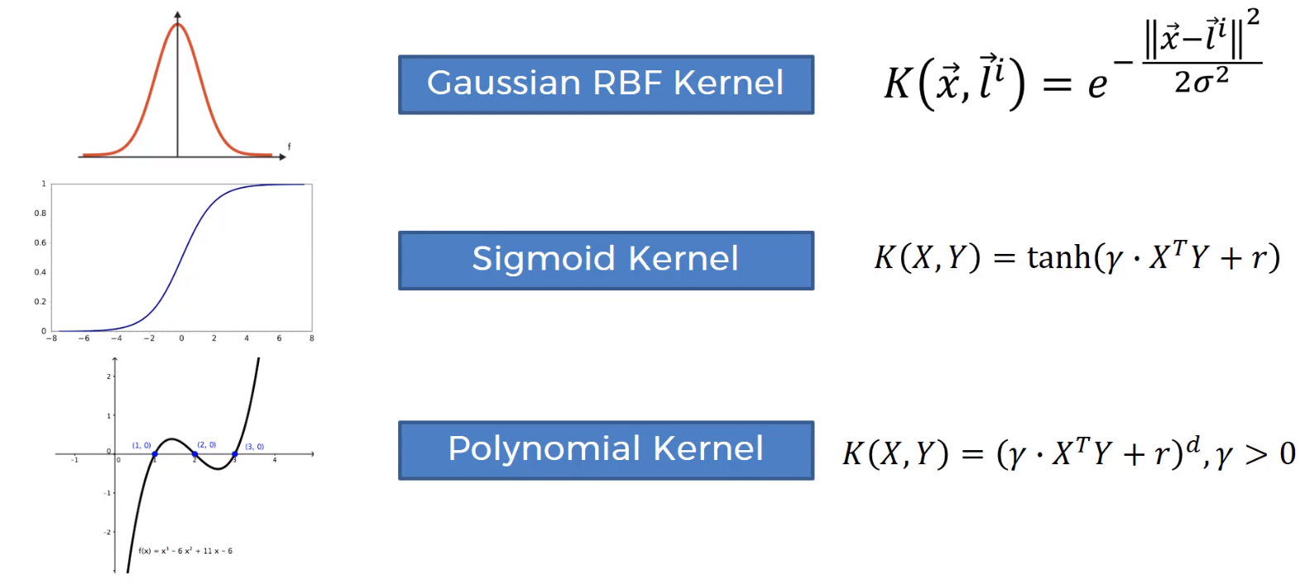

Refer Notes to know more about Kernel SVM.

**Naïve Bayes Classification-**

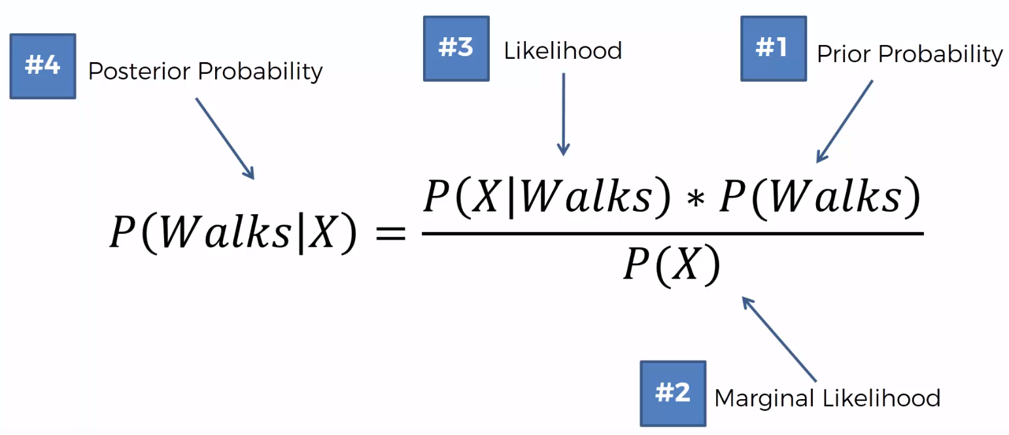

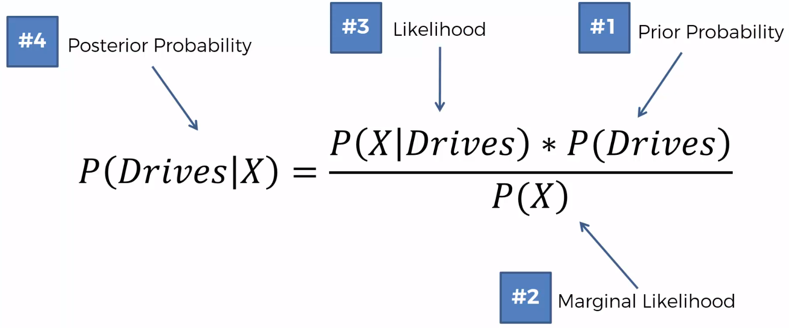



**Solution -**

Given a new data point, how to calculate where it belongs to or how to classify it?

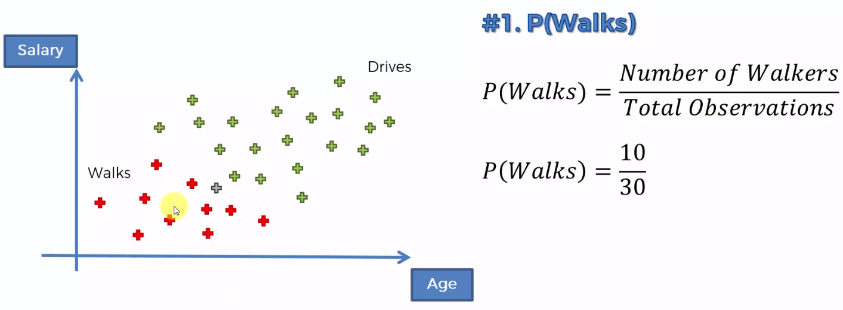

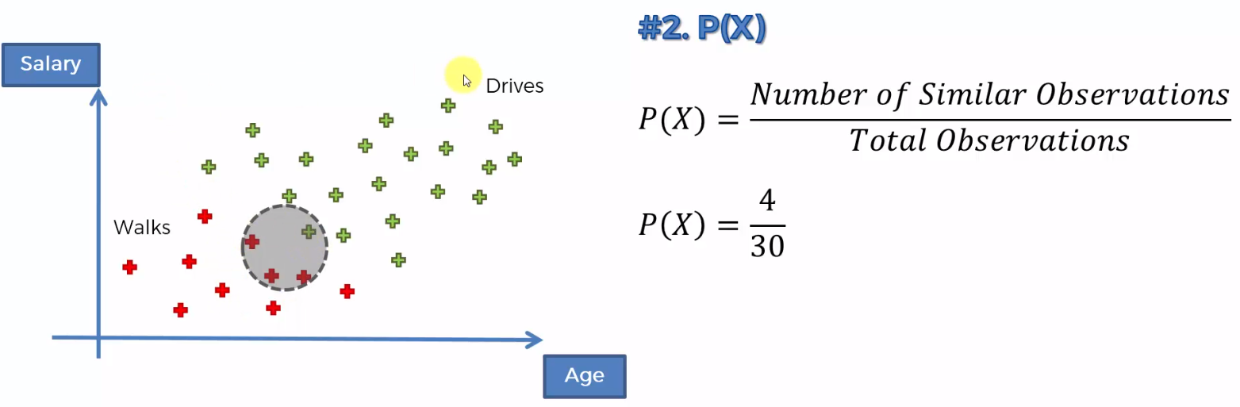

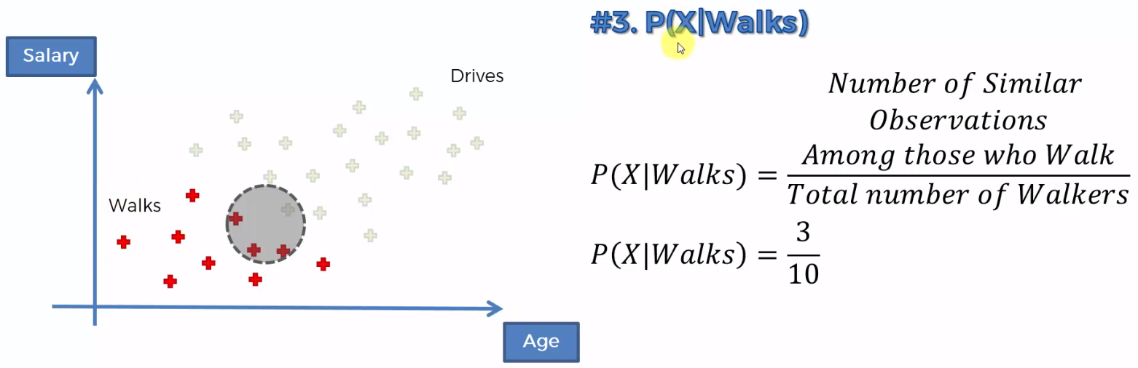

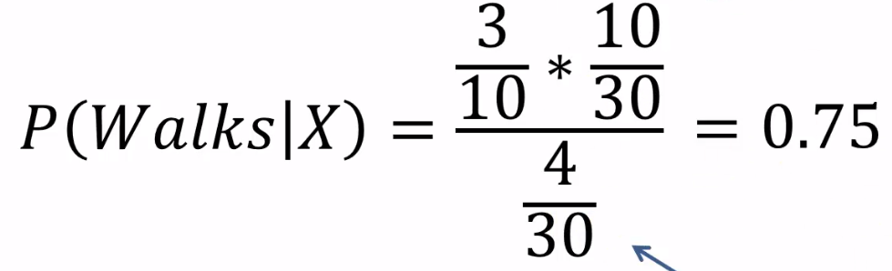 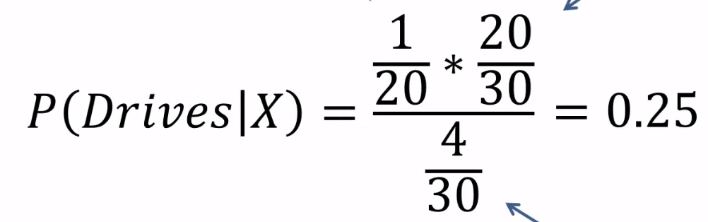



The new point belongs to Walks!

* Independence Assumptions – Naïve

The salary and the age variables are not completely independent. There is correlation between them.

* P(X) – A randomly selected point from the dataset will exhibit the features similar to the data point that we are about to add. And anything in that circle is deemed to be similar to our data point.

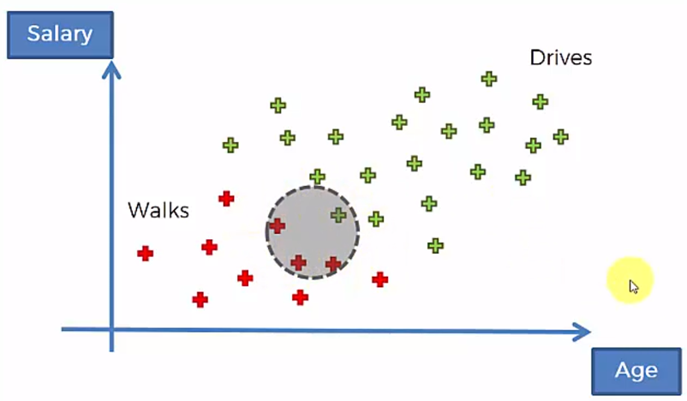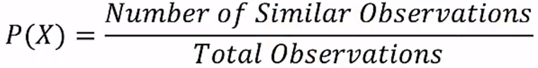

Since denominator is same for both the formulas, we eliminate **P(X)**.

* What happens if there are more than two features?

You need to calculate probabilities for all the classes/ features.

**Decision Tree Classification** –

CART – Classification and Regression Trees

Classification Trees –

It will cut up the data points into slices in several iterations. Basis of split – How is the split selected? Split is done in such a way to maximize the number of data points in each category of split. It minimizes information entropy.

If there is mix of data points in any split, then probabilistic classifier is used to decide which category the new data point falls in. We check what is the likelihood of it being red or green.

Upgrades of Decision Trees – Random Forest and Gradient Boosting

**Note : When your algorithm is based on Euclidian distance, only then will you perform feature scaling. Since decision tree is not based on Euclidian distance, you need not perform feature scaling. Besides, you need to interpret the prediction regions.**

In decision tree algorithm, we use criterion as entropy because we want high information gain. We want all the nodes in the leaf after split as homogeneous as possible (Users of same class). It measures the quality of split. More the similarity of nodes in the split, the entropy is reduced from parent node to the child node. After the split, if the entropy of child node is 0, then the split has a fully homogeneous group of users with users of the same class and the information gain is the entropy difference before and after the split. Higher the information gain is, more homogeneous the group is after the split.

Graph – Prediction Boundary consists of only horizontal and vertical lines. It kinds of overfit.

Prevent over fitting rather than have zero wrong predictions.

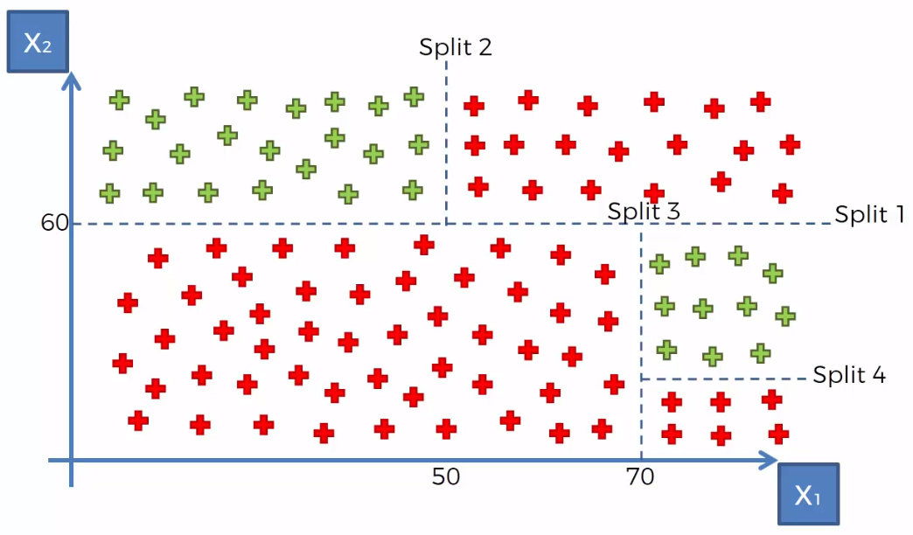

**Decision Tree** –

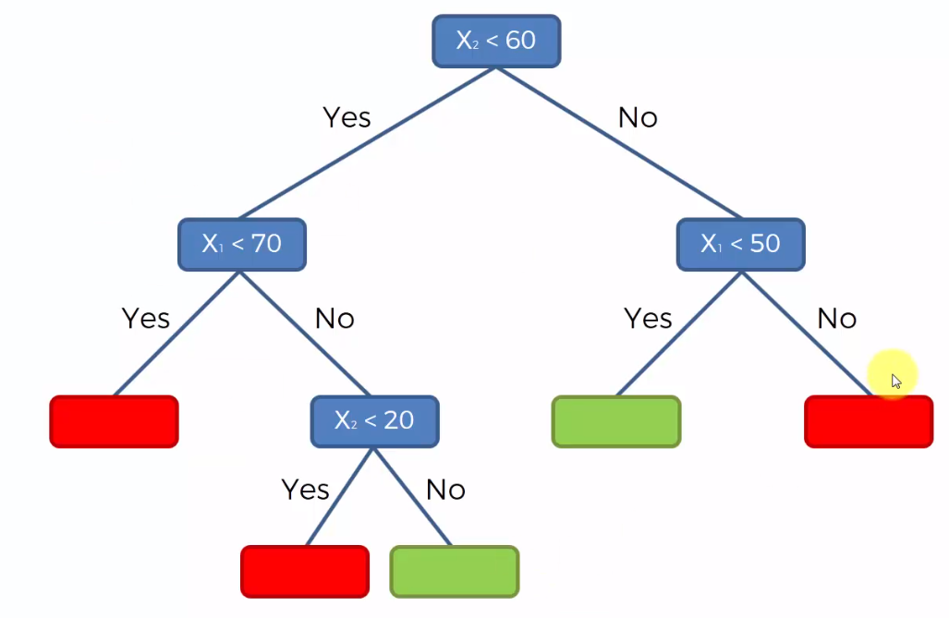

**Random Forest Classifier –**

Ensemble Learning – When you take multiple machine learning algorithms, put them together to make a bigger machine learning algorithm. Leveraging / using machine learning algorithms.

Random Forest – Using multiple decision tree algorithms. It avoids certain uncertainties and errors and increase precision.

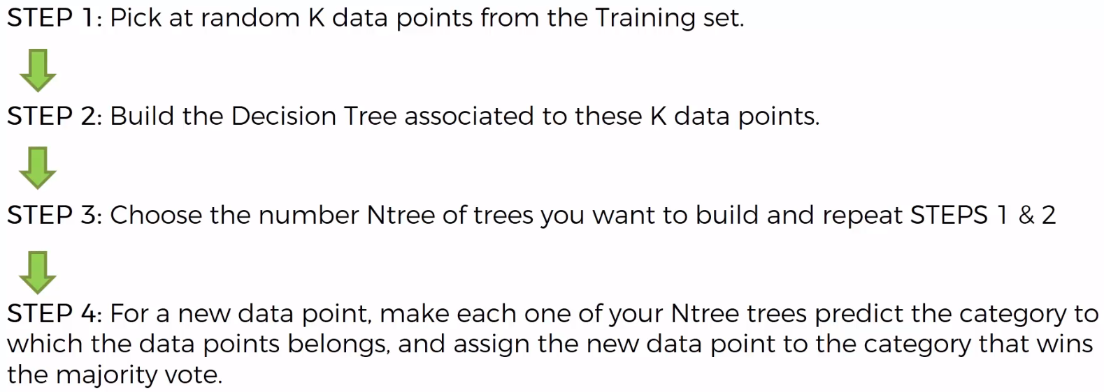

**False Positives and False Negatives -**

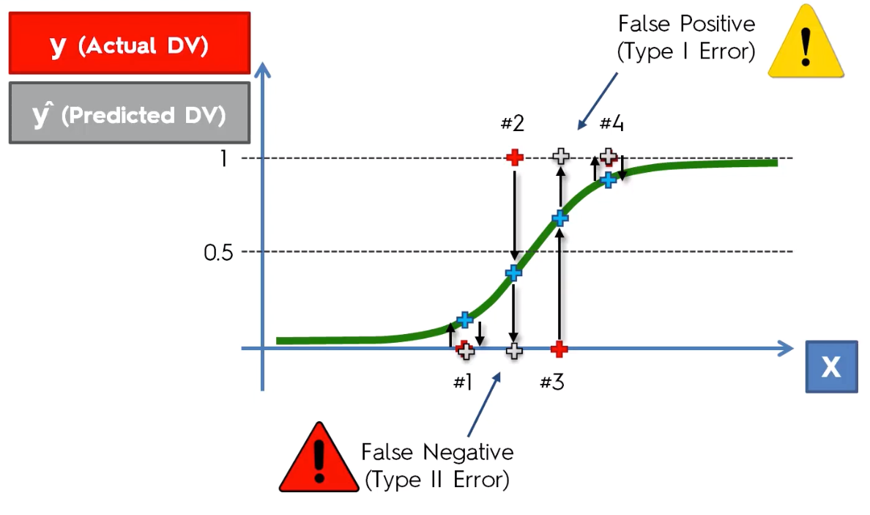

**Confusion Matrix -**

False Positive – When you predict something will happen, but it won’t happen.

False Negative – When you predict something won’t happen, but it will happen.

False Negative dangerous than False Positive.

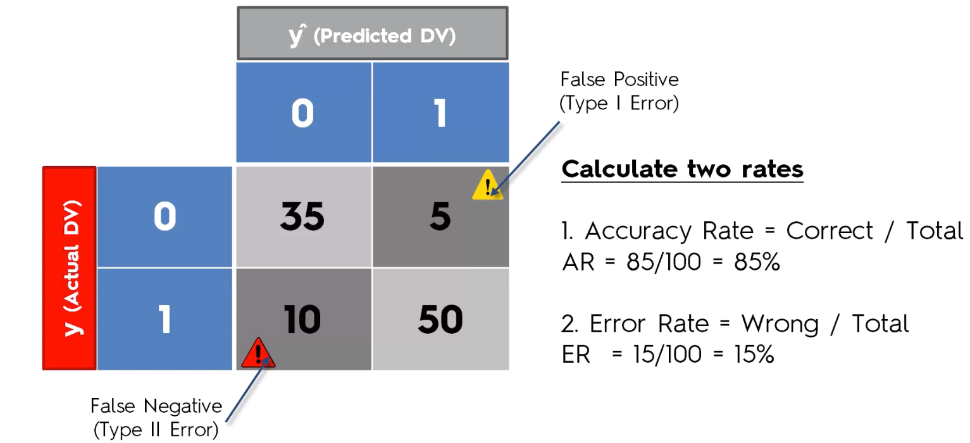

How to choose model for a classification problem?

Same as for regression models, you first need to figure out whether your problem is linear or non linear.

If your problem is linear, you should go for Logistic Regression or SVM.

If your problem is non linear, you should go for K-NN, Naive Bayes, Decision Tree or Random Forest.

Then which one should you choose in each case ?

Then from a business point of view, you would rather use:

- Logistic Regression or Naive Bayes when you want to rank your predictions by their probability. For example if you want to rank your customers from the highest probability that they buy a certain product, to the lowest probability. Eventually that allows you to target your marketing campaigns. And of course for this type of business problem, you should use Logistic Regression if your problem is linear, and Naive Bayes if your problem is non linear.

- SVM when you want to predict to which segment your customers belong to. Segments can be any kind of segments, for example some market segments you identified earlier with clustering.

- Decision Tree when you want to have clear interpretation of your model results,

- Random Forest when you are just looking for high performance with less need for interpretation.

**Clustering -**

**K-means Algorithm-**

K-Means algorithm allows us to cluster our data, convenient tool for discovering categories or groups in the dataset.

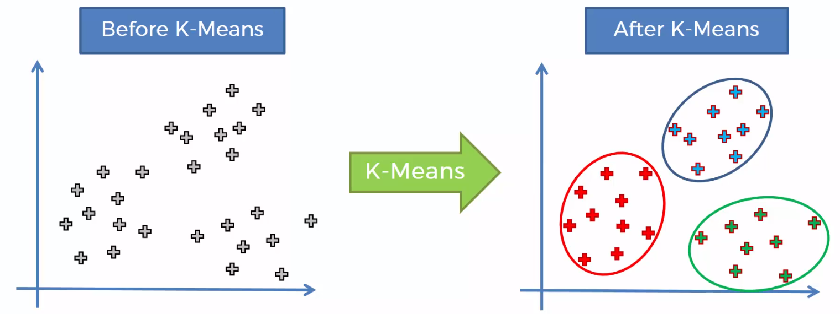

It can handle multiple dimensions also. It identifies clusters of data points.

Process of K-Means Clustering –

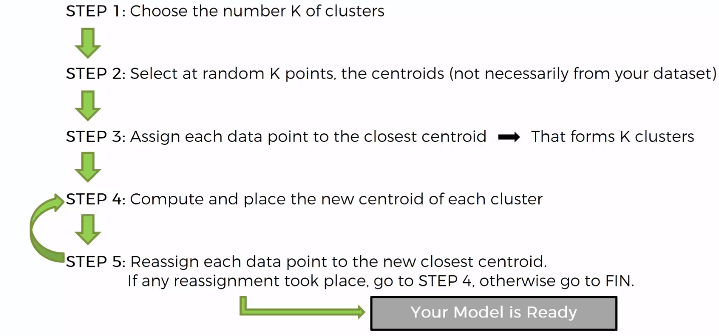

Process of assigning data points to centroid –

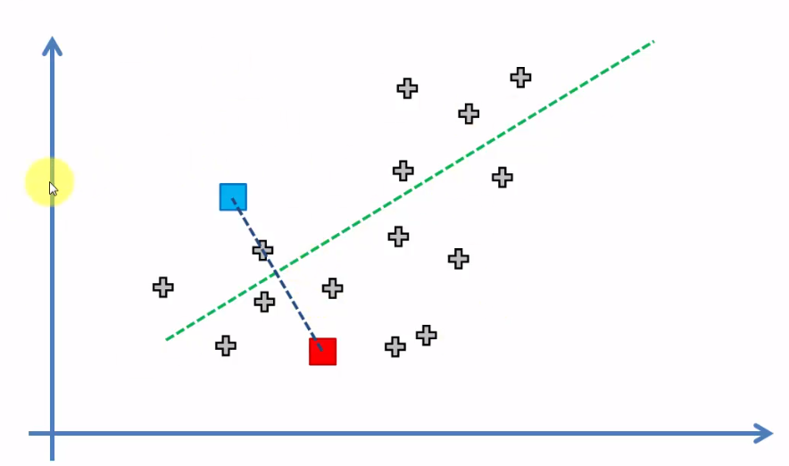

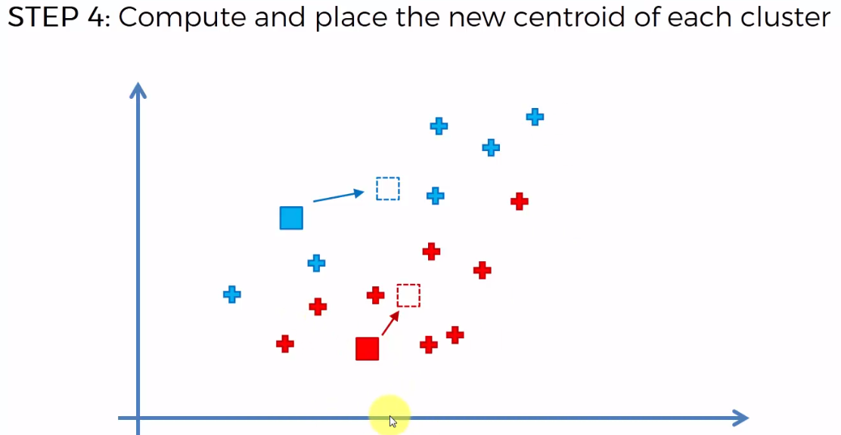

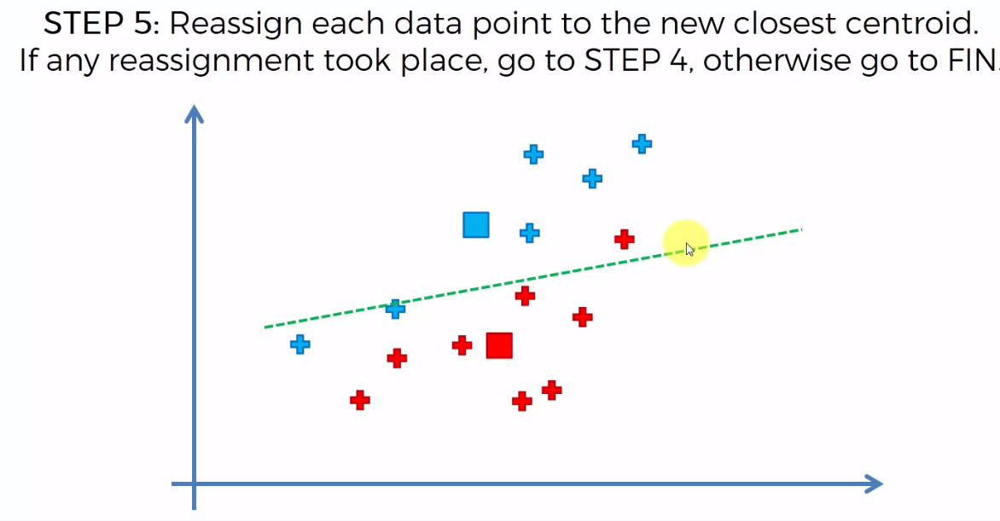

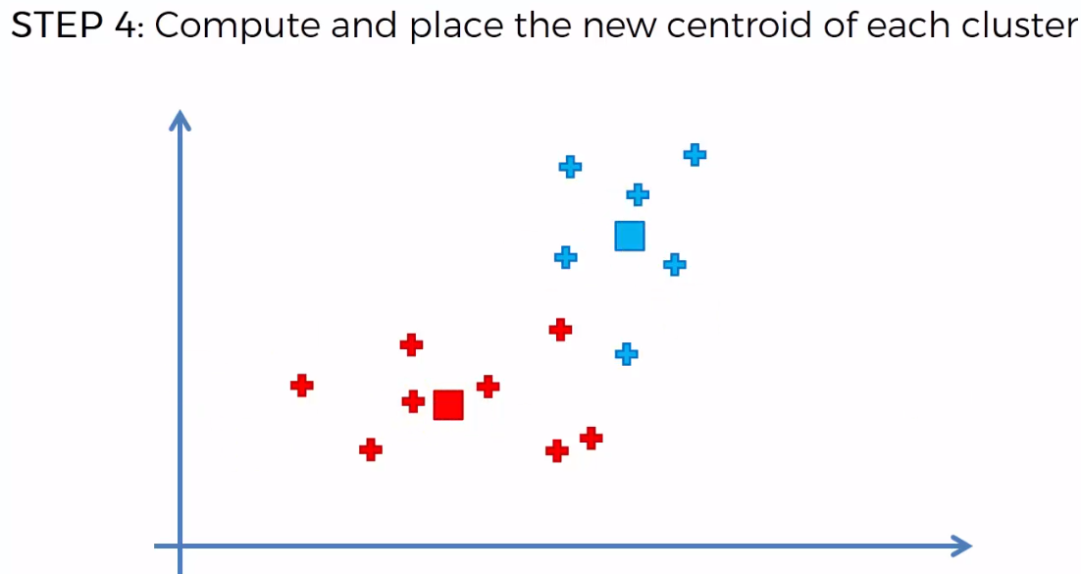

It is an iterative process, and goes on until the algorithm converges. It means that no data point has to be re-assigned.

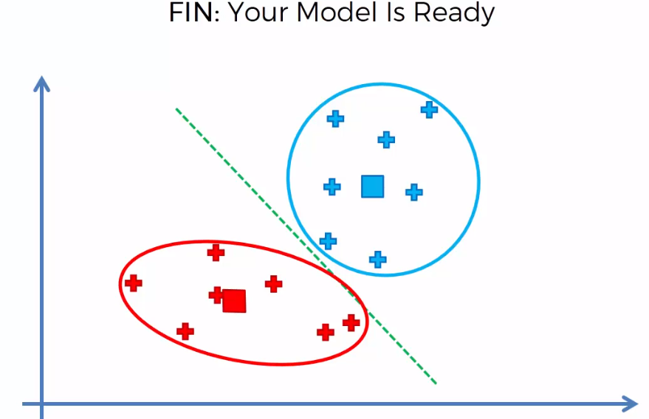

**Random Initialization Trap -**

Selection of centroids can potentially dictate the outcome of algorithm. It is not good because, centroids are selected at random. Solution is – **Kmeans ++** algorithm.

Selecting Number of clusters in Kmeans – To decide the how many number of clusters is required for our system, we evaluate using a formula called – **Within-Cluster Sum of Squares**



WCSS decreases from a good value to 0 when we have 1 cluster to number of clusters = number of data points.

Optimal number of clusters is that point where you can see a elbow – where the value of WCSS goes from substantially high value to a value that decreases constantly. (Number of clusters = 3 in the below graph)

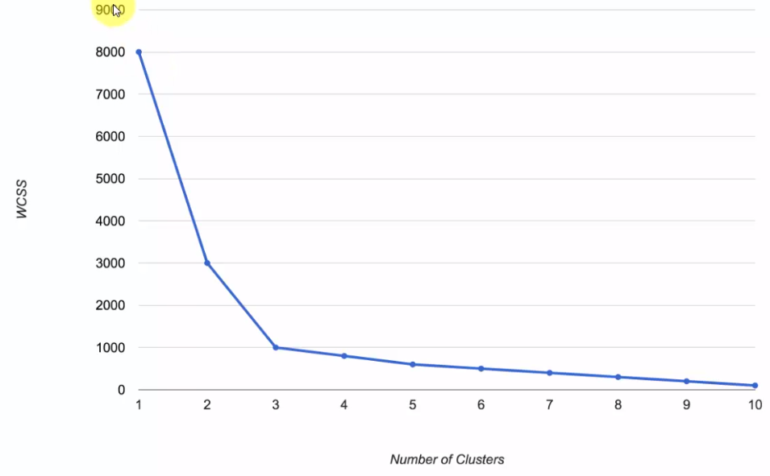

**Optimal number of clusters**

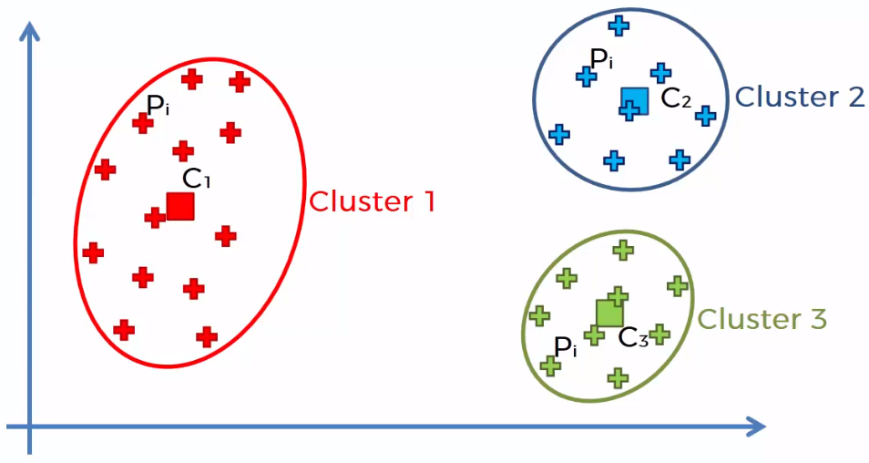

**Hierarchical Clustering -**

Two types of hierarchical clustering –

1. Agglomerative – Bottom Up approach

2. Divisive – Top Bottom Approach

**Agglomerative HC –**

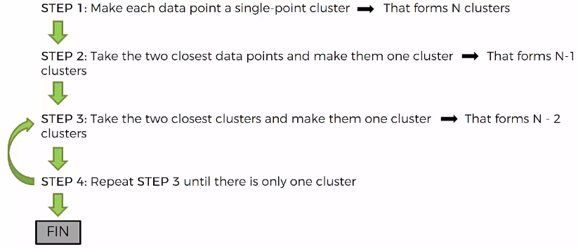

Closest Clusters – We are talking about proximity of clusters.

How do you measure distances between clusters?

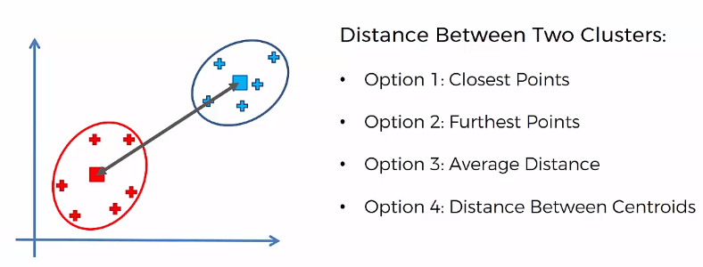

The hierarchical cluster maintains the memory of each step in process of forming a single cluster in a dendrogram.

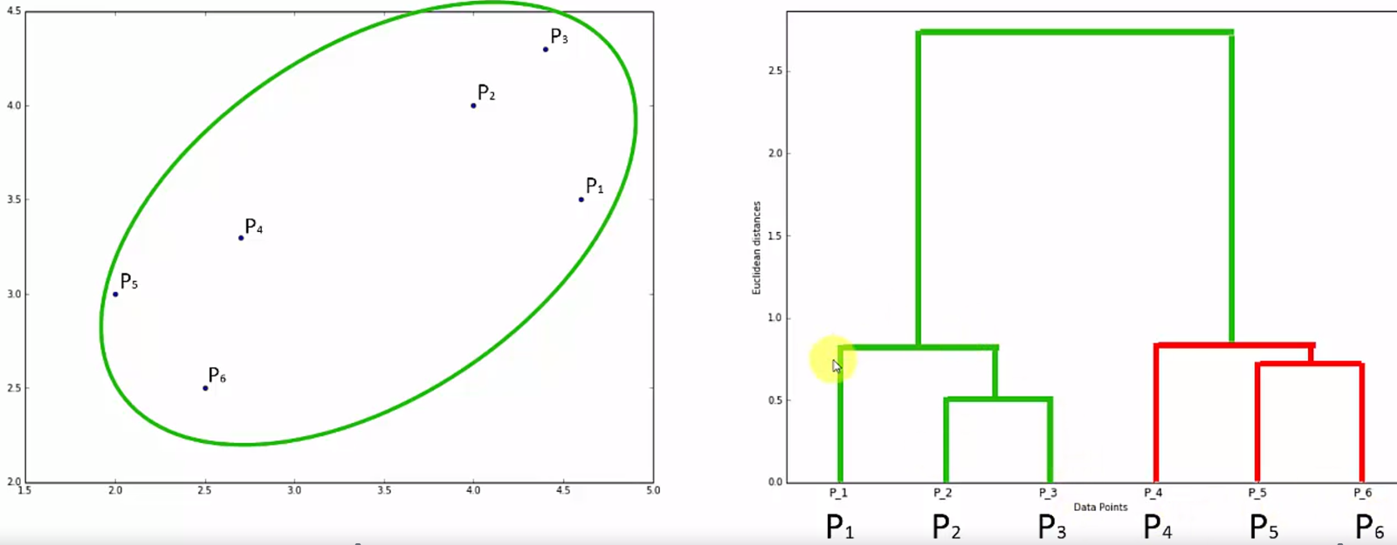

Dendrogram built using bottom-up approach.

Optimal threshold value in the dendrogram gives you optimal number of clusters. (Draw a horizontal straight line at y=optimal-value parallel to X-axis in the dendrogram. The number of vertical lines that this horizontal line cuts through will give you optimal number of clusters).

Find the highest vertical line in the dendrogram. Since dendrogram gives you dissimilarity between two clusters.

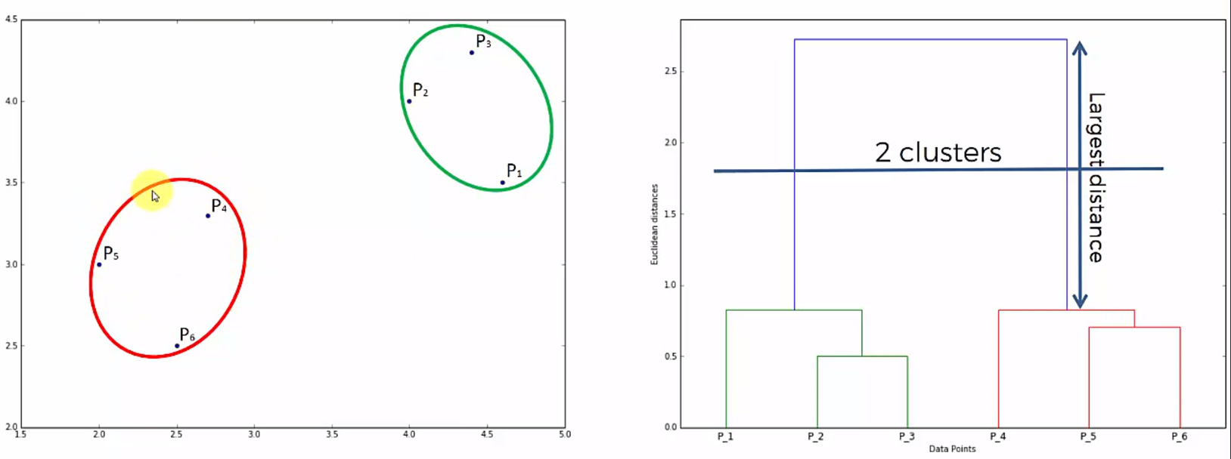

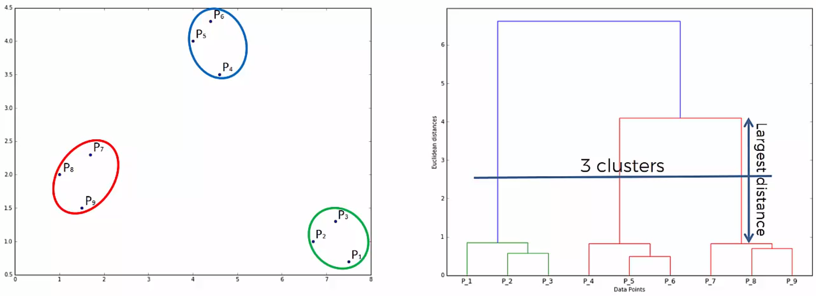

Dendrograms are based on within cluster variance.

On large datasets, K-Means clustering perform better than hierarchical clustering.

**Association Rule Learning Models -**

1. Apriori

2. Eclat

**Apriori –** People who bought this also bought that…

Examples -

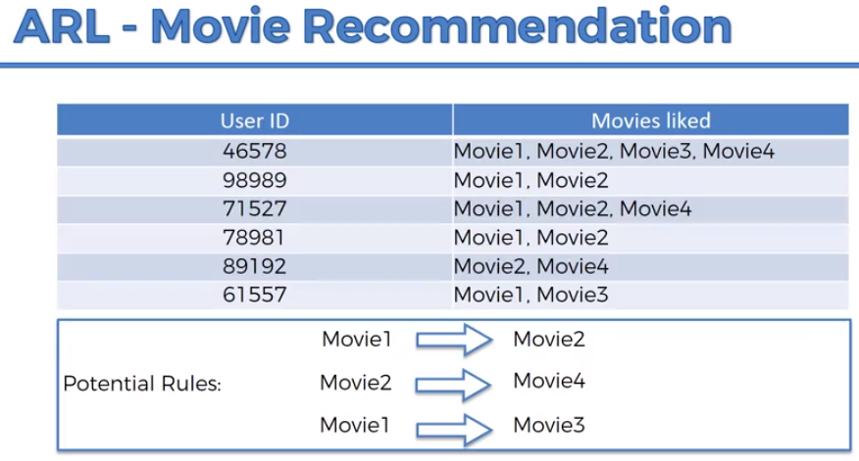

Sample size should be huge (50000 or more) to analyze.

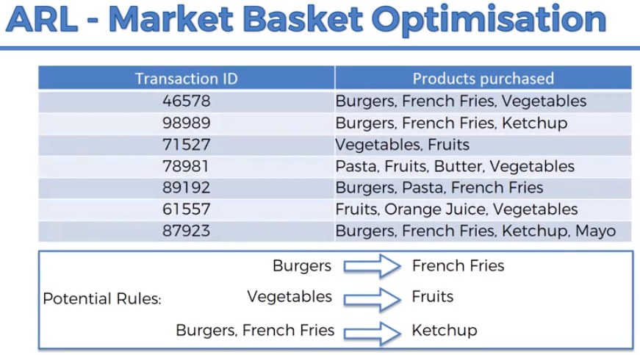

Apriori algorithm has 3 parts to it –

**1.** **Support –**

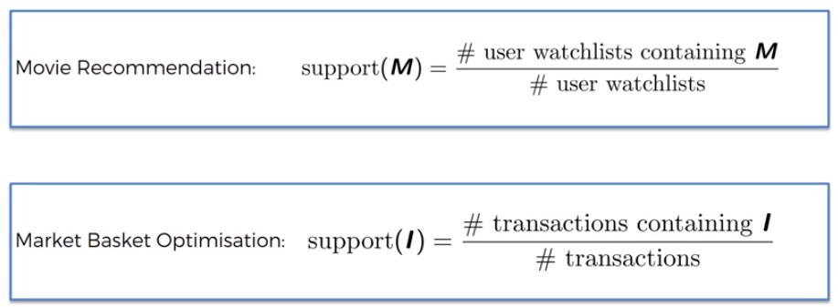

**2. Confidence**

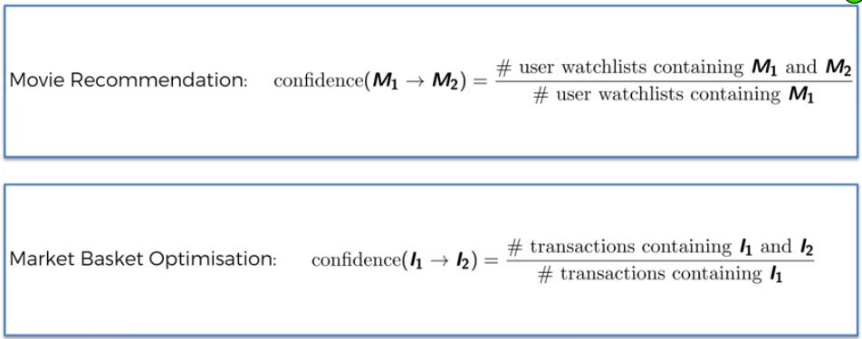

**3. Lift**

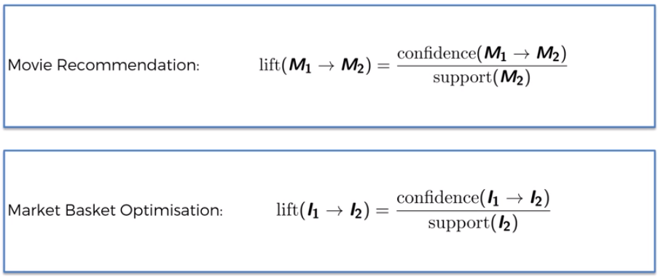

**Apriori Algorithm –**

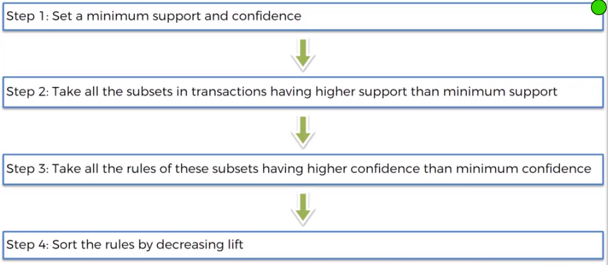

**Eclat Model -** Similar to Apriori Algorithm (Recommendation System)

In Eclat model, we have only support.

M and I stand for a set of items – How frequently does this set of items occur? Aiming at least two items in the list.

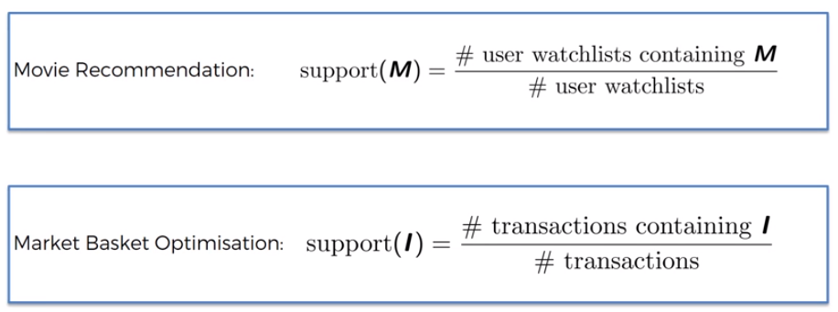

**Algorithm -**

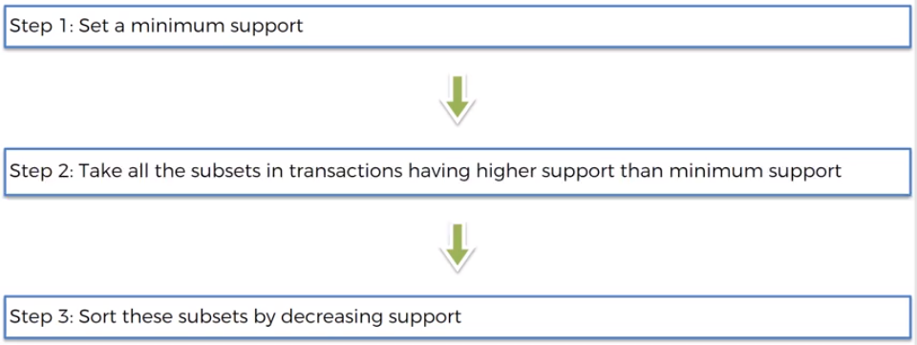

**Reinforcement Learning –**

Reinforcement Learning is a branch of Machine Learning, also called Online Learning. It is used to solve interacting problems where the data observed up to time t is considered to decide which action to take at time t + 1. It is also used for Artificial Intelligence when training machines to perform tasks such as walking. Desired outcomes provide the AI with reward, undesired with punishment. Machines learn through trial and error.

There are two Reinforcement Learning models:

1. Upper Confidence Bound (UCB)
2. Thompson Sampling

**Multi-Armed Bandit Problem -**Exploration and Exploitation



Distribution of Numbers on different machines –

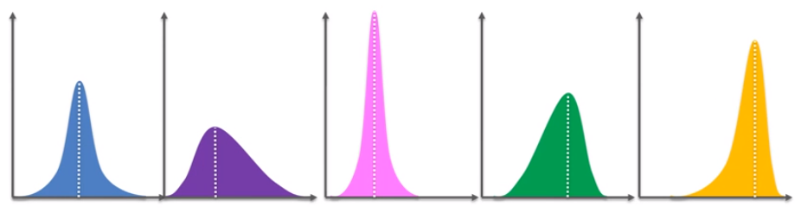

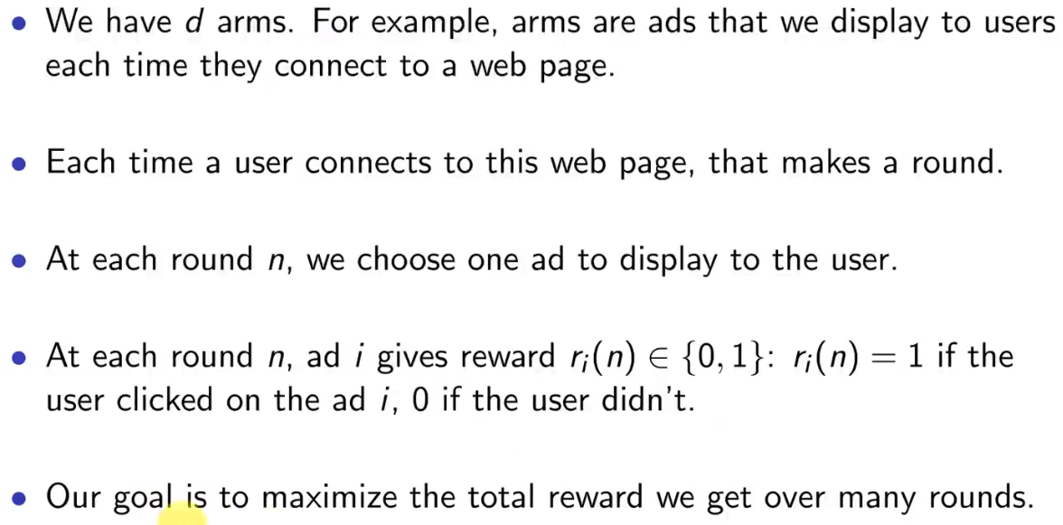

**Upper Confidence Bound Algorithm–**

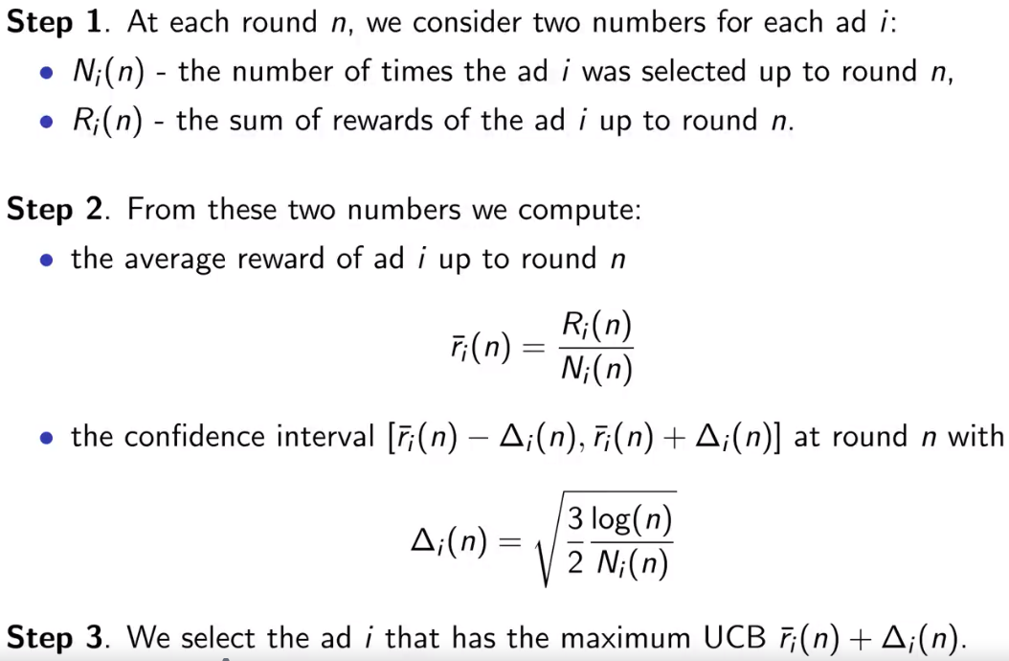

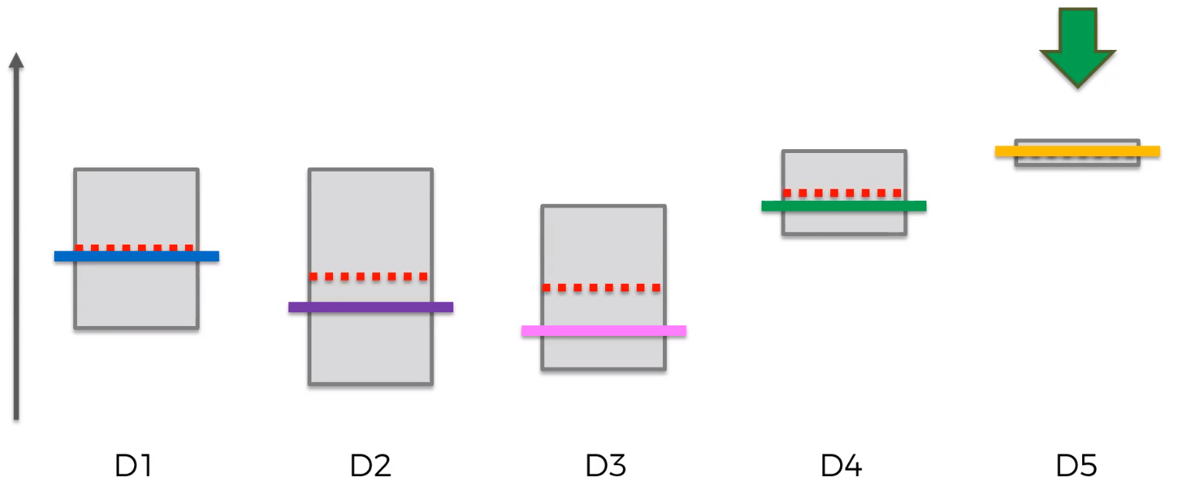

**Thompson Sampling –**

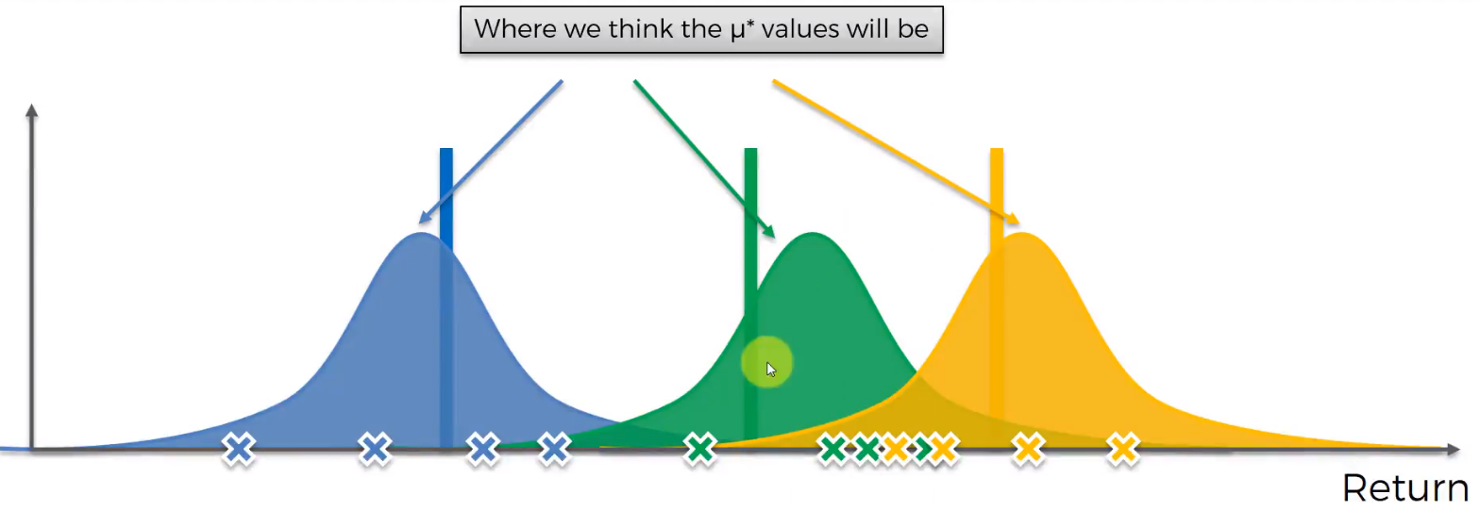

The algorithm creates distribution for each machine depending on the first 4 rounds.

This is a probabilistic model rather than deterministic model in the UCB Algorithm.

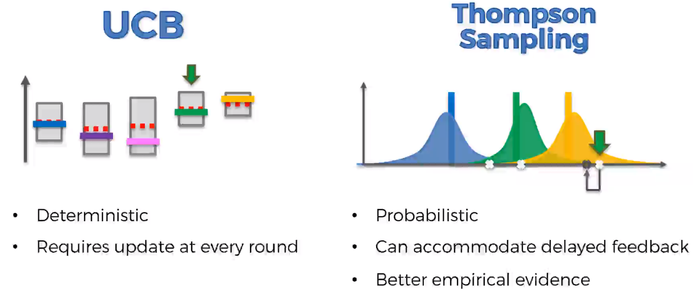

**Natural Language Processing -**

Natural Language Processing (or NLP) is applying Machine Learning models to text and language. Teaching machines to understand what is said in spoken and written word is the focus of Natural Language Processing. Whenever you dictate something into your iPhone / Android device that is then converted to text, that’s an NLP algorithm in action.

You can also use NLP on a text review to predict if the review is a good one or a bad one. You can use NLP on an article to predict some categories of the articles you are trying to segment. You can use NLP on a book to predict the genre of the book. And it can go further, you can use NLP to build a machine translator or a speech recognition system, and in that last example you use classification algorithms to classify language. Speaking of classification algorithms, most of NLP algorithms are classification models, and they include Logistic Regression, Naive Bayes, CART which is a model based on decision trees, Maximum Entropy again related to Decision Trees, Hidden Markov Models which are models based on Markov processes.

A very well-known model in NLP is the Bag of Words model. It is a model used to preprocess the texts to classify before fitting the classification algorithms on the observations containing the texts.

Different process in NLP -

* Clean texts to prepare them for the Machine Learning models,
* Create a Bag of Words model
* Apply Machine Learning models onto this Bag of Worlds model.

**Word embeddings** - Similar words clustered near by each other

NLP can used to learn word embeddings, learn relationship between words (Male – Female , Walking – Walked, Country- Capital, Ex – Gender , Verb – Tense, Country – Capital relationships)

TSV – Tab Separated Values (Easy to differentiate between review and the its type (0/1))

Before actually going ahead and predicting the words, we need to perform text processing/ clean the text to create bag of words model that has only relevant an useful words that help ML algorithm to predict if review is positive or negative.

* Remove irrelevant words (on, the, and – Articles, Prepositions)
* Remove punctuation marks
* Remove numbers
* Change to lower case from uppercase
* Stemming (Get root words, to group different versions of same word and not have too many words– love, loving, loved) – Helps in decreasing sparsity
* Tokenization – Split the sentences into different words

We create a sparse matrix as last step in creation of bag of words.

**Bag of Words Model –** Take all the unique different words of all the reviews, create one column for each word. The rows correspond to the review. Each cell in this table will correspond to one specific word and one specific review. Most of the cells will contain 0. This is called **Sparse Matrix.** This is done in the process of tokenization. You can reduce the sparsity by using Dimensionality Reduction. In NLP, most of the times – Naïve Bayes and Decision Tree Algorithms are used.